SUBCOURSE EDITION
OD0478 7

PRINCIPLES AND TROUBLESHOOTING OF THE
POWER TRAIN ON THE M1 TANK

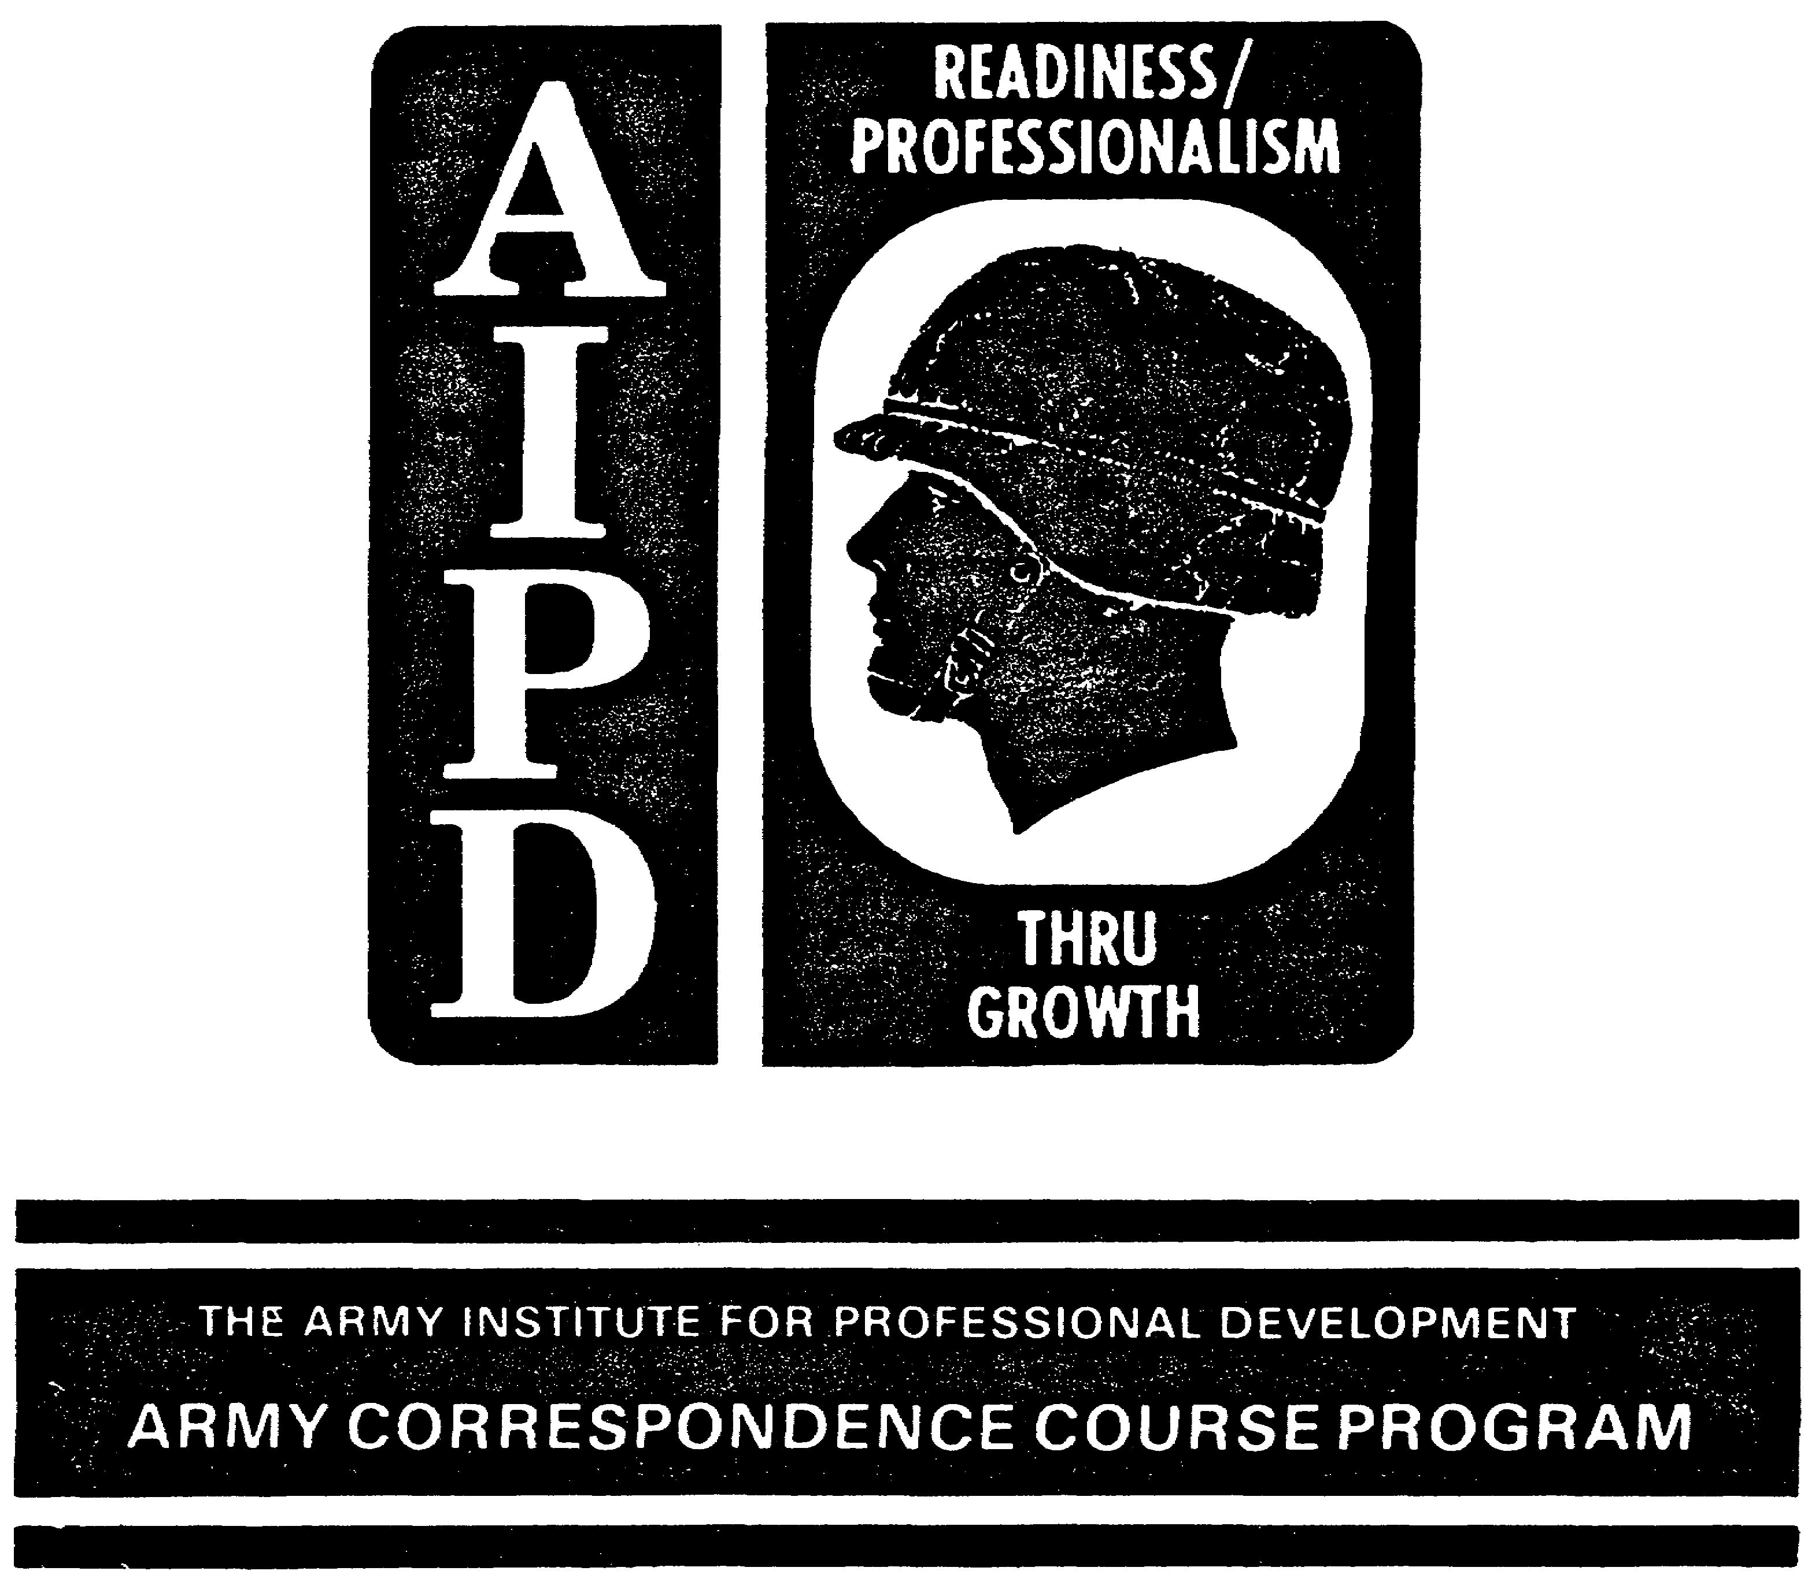

TANK SYSTEMS MECHANIC

MOS/SKILL LEVEL: 63E30

PRINCIPLES AND TROUBLESHOOTING OF THE
POWER TRAIN ON THE M1 TANK

SUBCOURSE NO. OD 0478
Edition 7

United States Army Combined Arms Support Command
Fort Lee, Virginia 23801-1809

6 Credit Hours

GENERAL

The purpose of this subcourse is to introduce the principles of operation of the power train on the M1 tank, including the function and operation of the power train components, and to describe typical troubleshooting procedures for the M1 power train.

The scope of this subcourse covers a general introduction to the overall operation of the M1 tank power train. The subcourse also provides an explanation of the operation of the various power train components. The typical procedures for isolating malfunctions and troubleshooting the power train components are also discussed.

Six credit hours are awarded for successful completion of this subcourse. It consists of two lessons, divided into tasks as follows:

Lesson 1: PRINCIPLES OF THE POWER TRAIN ON THE M1 TANK

TASK 1: Identify the principles and functions of the power train.

TASK 2: Describe the operation of components of the power train.

i

PRINCIPLES & T/S M1 POWER TRAIN - OD 0478

Lesson 2: MALFUNCTIONS AND TROUBLESHOOTING
PROCEDURES FOR THE POWER TRAIN ON
THE M1 TANK

TASK 1: Describe the procedures to be used in troubleshooting and isolating malfunctions of the power train on the M1 tank.

ii

PRINCIPLES & T/S M1 POWER TRAIN - OD 0478

TABLE OF CONTENTS

Section Page

TITLE i

TABLE OF CONTENTS iii

Lesson 1: PRINCIPLES OF THE POWER TRAIN
ON THE M1 TANK 1

Task 1: Identify the principles and
functions of the power train 1

Task 2: Describe the operation of
components of the power train 6

Practical Exercise 1 17

Answers to Practical Exercise 1 19

Lesson 2: MALFUNCTIONS AND TROUBLESHOOTING
PROCEDURES FOR THE POWER TRAIN
ON THE M1 TANK 20

Task 1: Describe the procedures to be
used in troubleshooting and isolating
malfunctions of the power train on the
M1 tank 20

Practical Exercise 2 39

Answers to Practical Exercise 2 41

REFERENCES 42

iii

PRINCIPLES & T/S M1 POWER TRAIN - OD 0478 - LESSON 1/TASK 1

LESSON 1

PRINCIPLES OF THE POWER TRAIN ON THE M1 TANK

TASK 1. Identify the principles and functions of the power train.

CONDITIONS

Within a self-study environment and given the subcourse text, without assistance.

STANDARDS

Within one hour

REFERENCES

No supplementary references are needed for this task.

1. Introduction

Imagine sitting in a combat-loaded M1 tank under heavy enemy fire; a dangerous situation under any circumstances. But, suppose this M1 tank can't be moved or maneuvered. No power is available to move in forward or reverse, to turn, steer, or brake. The enemy approaches, but the M1 crew cannot effectively attack or retreat. The outcome of such a situation can only be a suicidal nightmare. Fortunately, such a nightmare need never occur. The M1 tank, known for its high degree of maneuverability, is equipped with a sophisticated power train which has been designed for ease of maintenance. And, fortunately, the M1 Abrams tank system mechanic is well trained in the maintenance necessary to keep the power train operational.

The power train on the M1 tank, located in the rear of the hull, provides the basic power to drive the tank. The power train has a turbine engine mated to an automatic transmission (figure 1 on the following page). Accessories on the power train provide hydraulic and electrical power for the tank

1

PRINCIPLES & T/S M1 POWER TRAIN - OD 0478 - LESSON 1/TASK 1

and its auxiliary systems. In order to perform effective maintenance, it is important that the M1 Abrams tank systems mechanic understands how the power train works, and how its various components operate to provide the propelling forces needed to move the tank. This subcourse is designed to introduce the principles of operation of the M1 power train and to provide a background in the troubleshooting procedures for isolating a malfunctioning power train component. Lesson one is divided into two tasks. The first describes the principles of power train operation; the second describes more specifically the operation of the components of the power train.

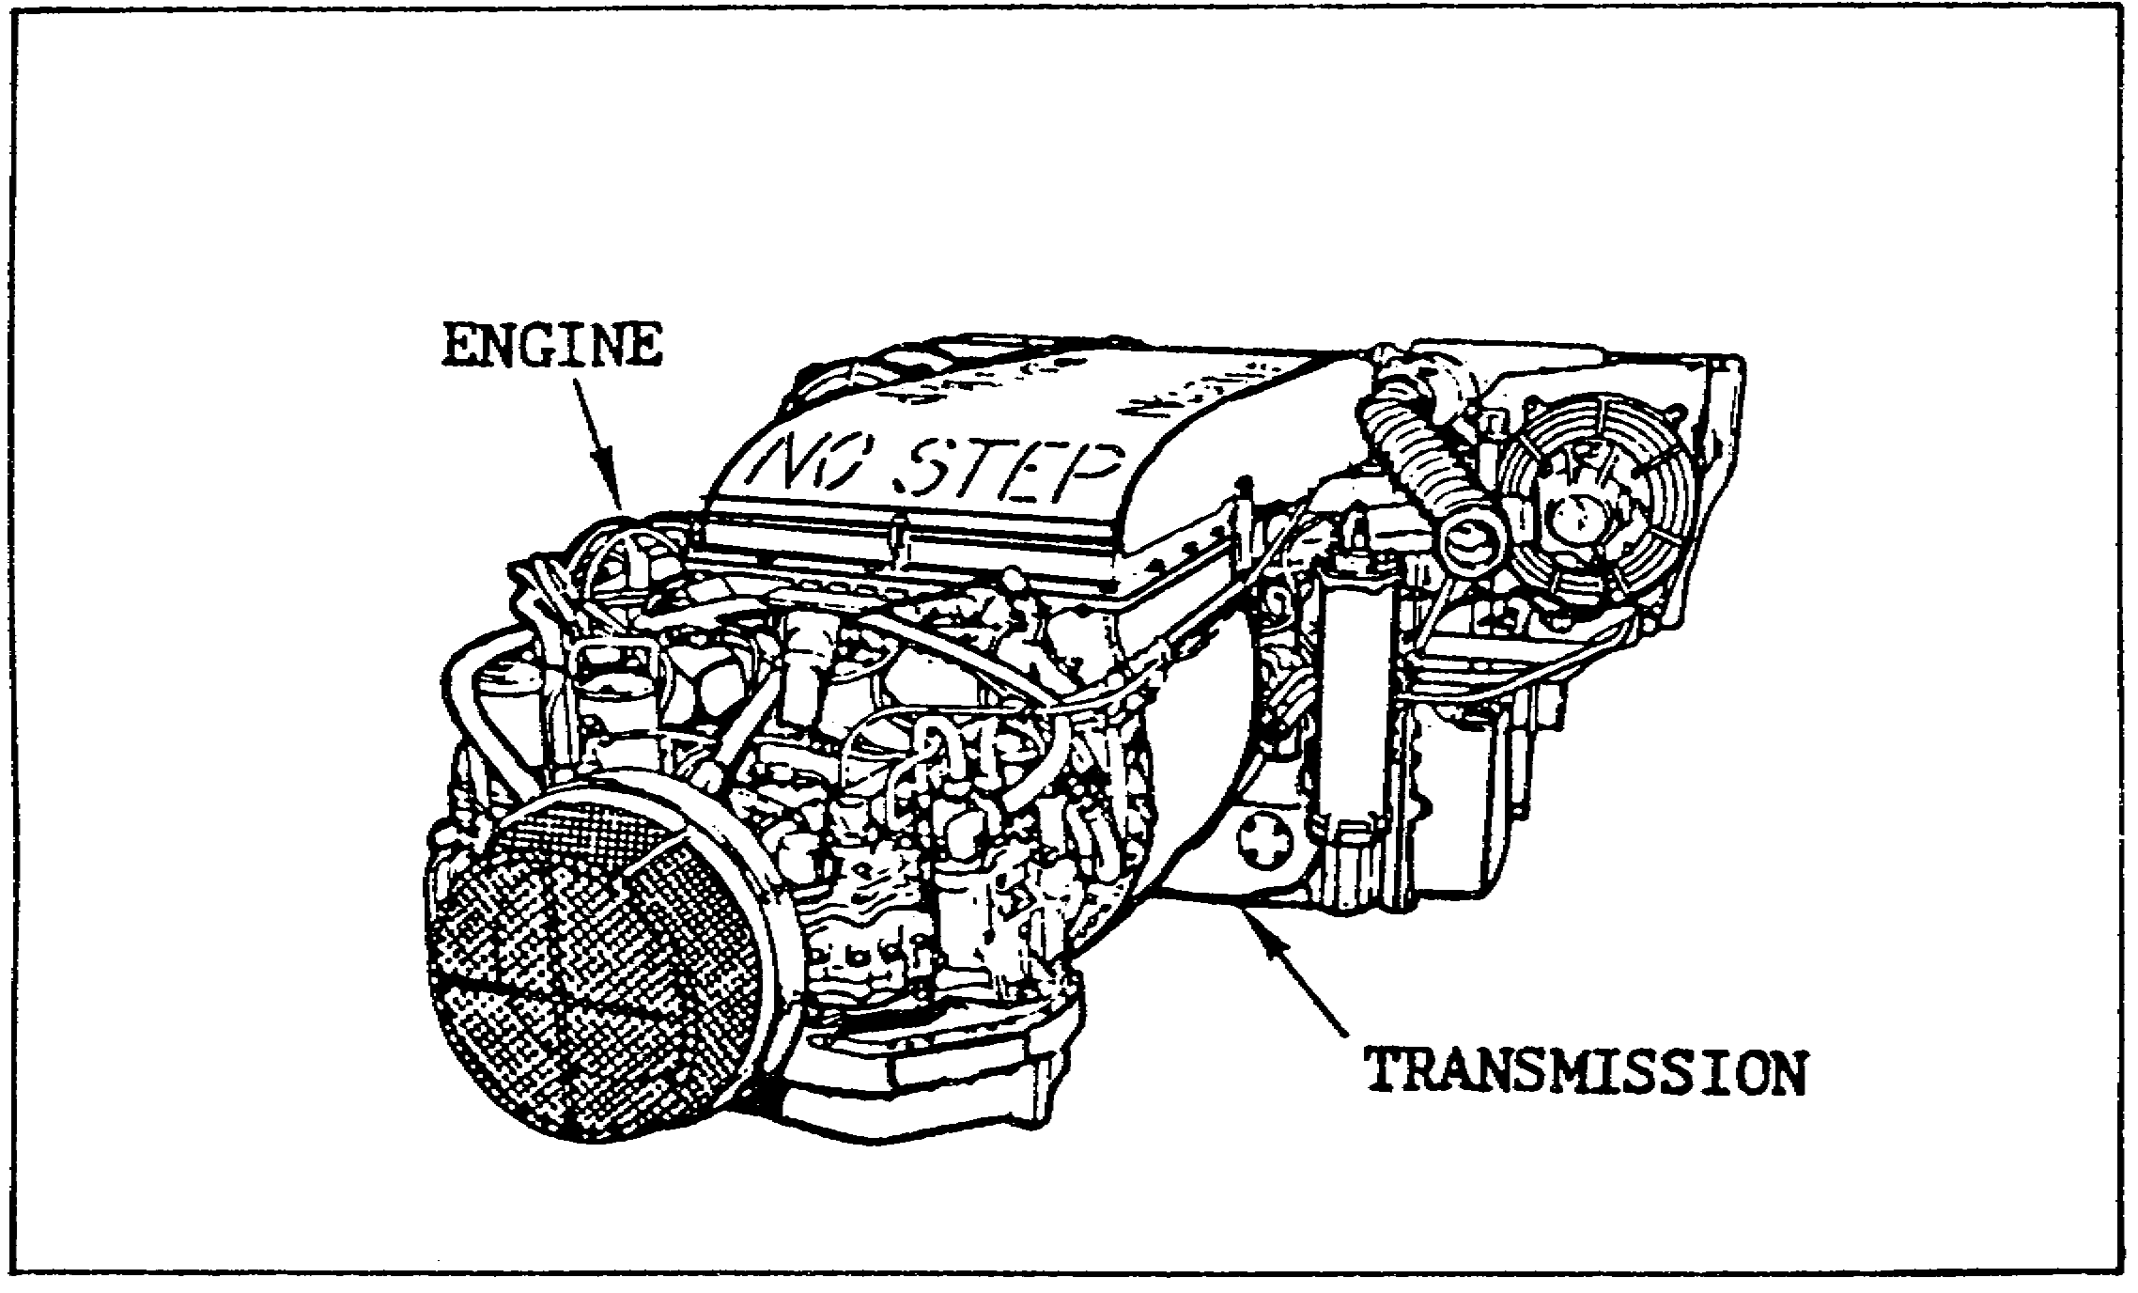

FIGURE 1. THE M1 ABRAMS POWER TRAIN.

2. The Turbine Engine

The engine provides power to the transmission, and thus to the final drives and tank tracks, so that the vehicle can be moved. The turbine engine on the M1 tank burns diesel fuel mixed with compressed and heated air. Air enters the engine air inlet and flows through two compressors. The compressed air is heated by exhaust gases to help in burning. The heated and compressed air is directed into the combustion chamber where it mixes with fuel vapor. Once burning is started by an ignition spark, continuous burning occurs. The engine drives the transmission through a reduction gearbox. Exhaust
2
PRINCIPLES & T/S M1 POWER TRAIN - OD 0478 - LESSON 1/TASK 1

gases leaving the power turbine are used to heat incoming air, and are then routed into the exhaust.

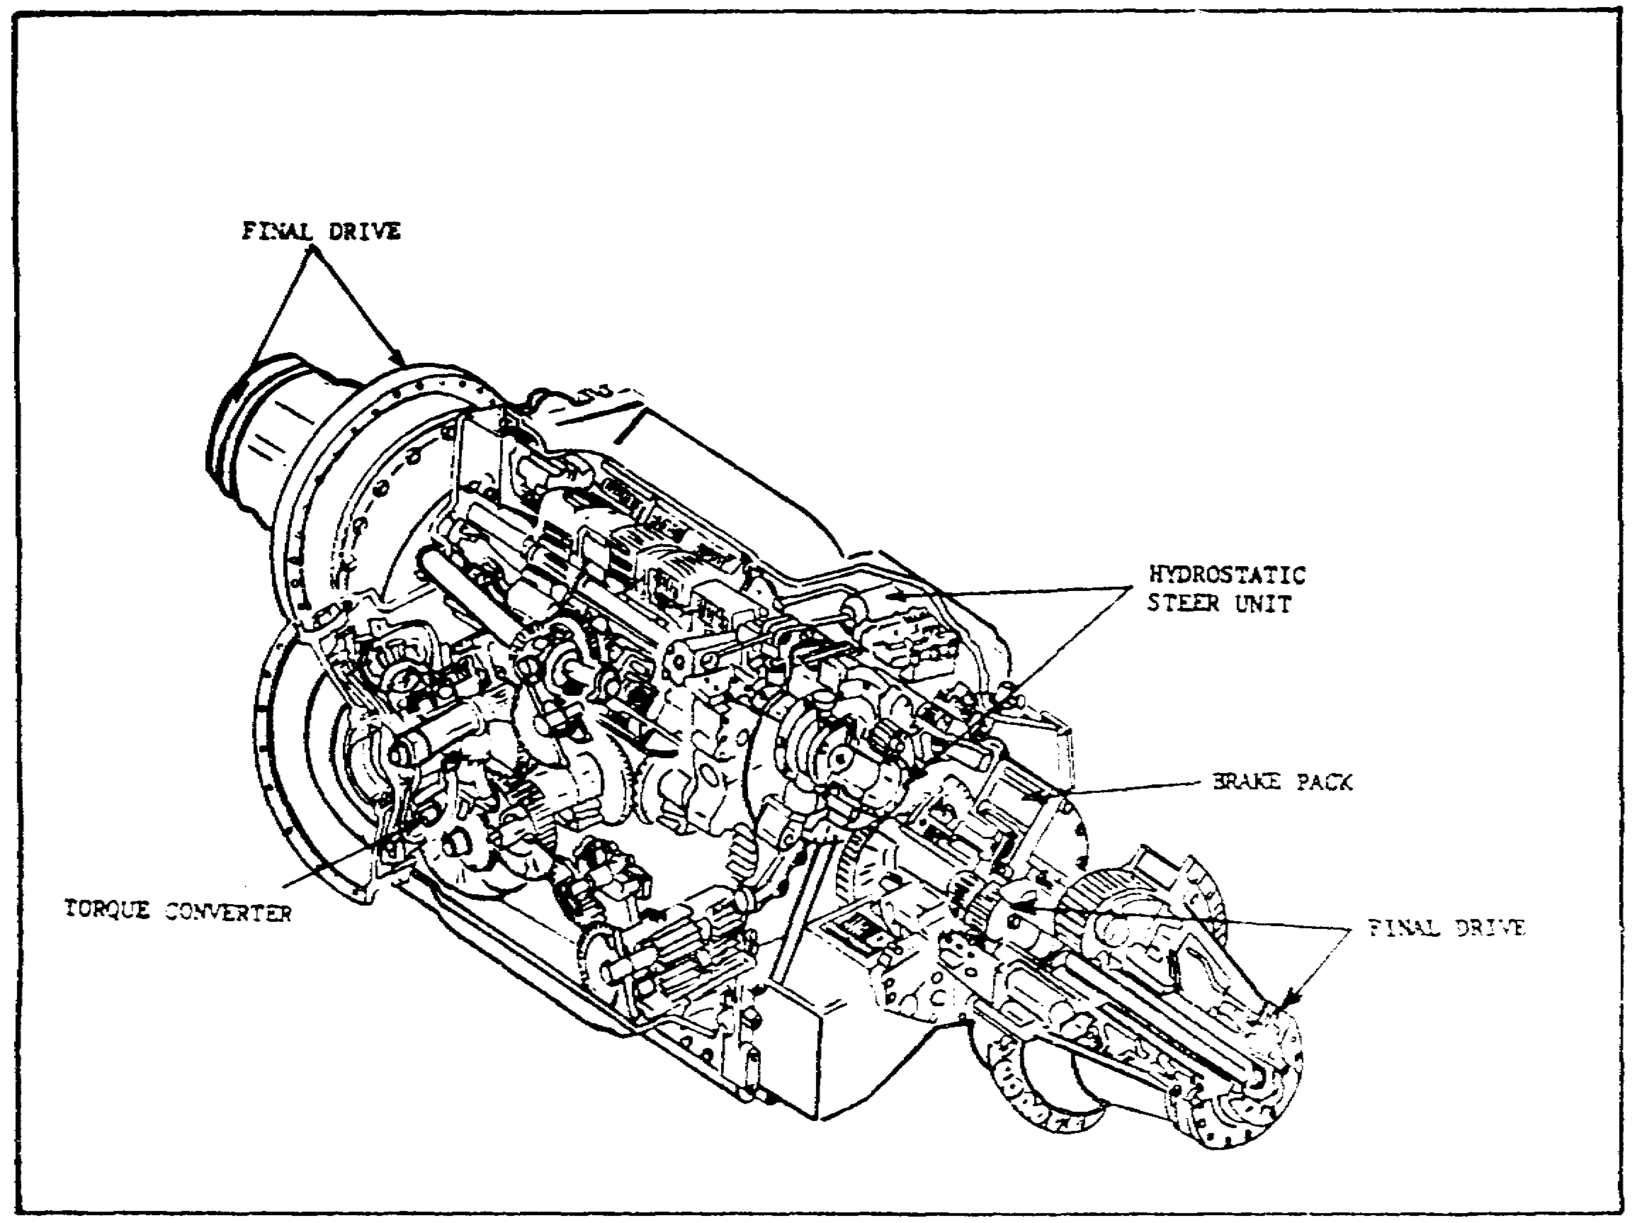

FIGURE 2. THE M1 TANK TRANSMISSION.

3. The Transmission and Final Drives

The purpose of the transmission is to provide the operator with a selection of gear ratios between the engine and the final drives so that the vehicle can operate at best efficiency under a variety of driving conditions and loads. Therefore, the transmission is a major part of the tank. The transmission sends power from the engine to the final drives. The final drives then send power to the tank's tracks. The fully automatic transmission (figure 2) on the M1 tank performs three functions: driving, steering, and braking. The transmission takes the engine power output and applies it to the left and/or right transmission outputs to perform these functions. The transmission power outputs transmit power through a final drive assembly on each side of the tank.

3
PRINCIPLES & T/S M1 POWER TRAIN - OD 0478 - LESSON 1/TASK 1

a. Drive Function. The transmission has four forward and two reverse gears. The driver can select low (L) and drive (D) forward ranges and one reverse (R) range on the transmission shift control. Transmission ranges are selected by energizing solenoid valves in the transmission. The solenoids energize when electrical signals are received from the shift select control on the steer-throttle control.

b. Steering Function. The steer-throttle control (figure 3) in front of the driver is mechanically linked to the transmission. The steer-throttle control is the method by which the driver controls the direction of tank travel.

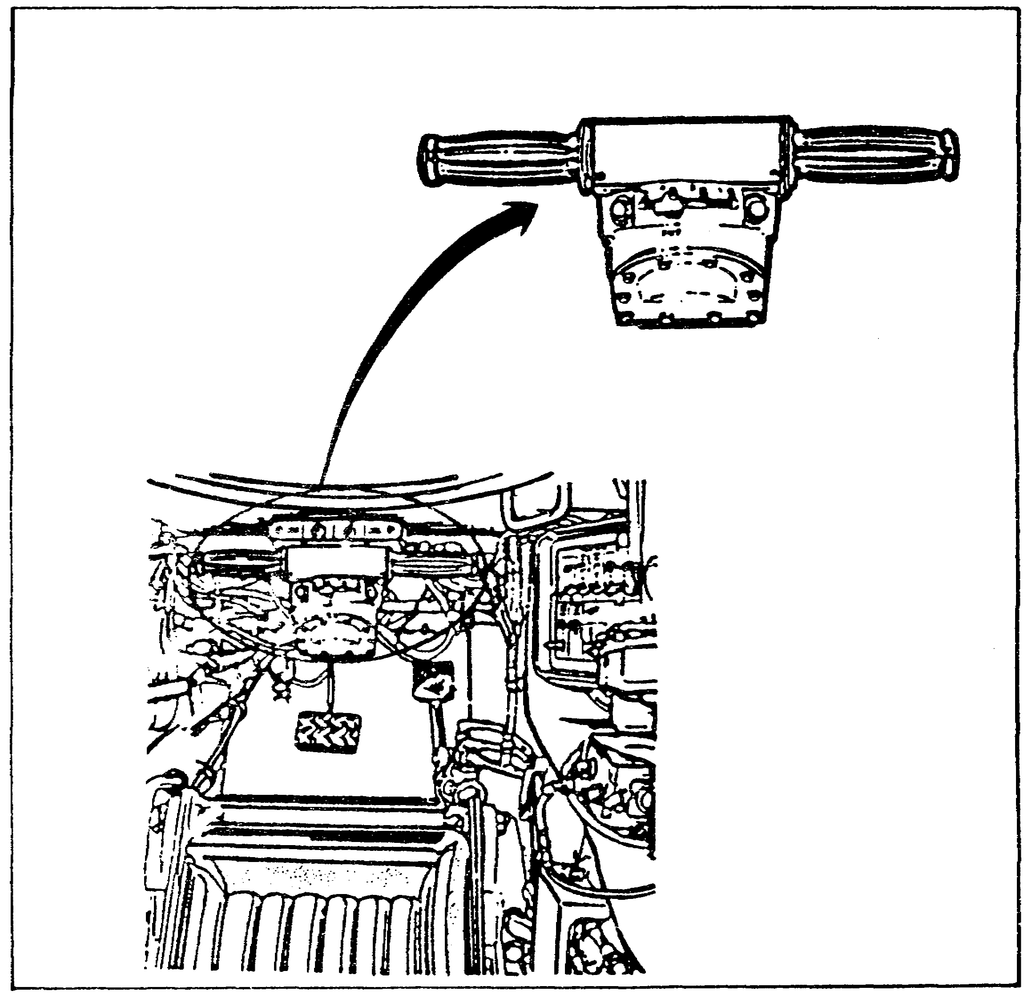

FIGURE 3. THE STEER-THROTTLE CONTROL.

4

PRINCIPLES & T/S M1 POWER TRAIN - OD 0478 - LESSON 1/TASK 1

c. The Braking Function. Two methods of braking are available to the driver. The driver's service brake pedal is normally used to slow or stop the tank. The parking brake is used to maintain a stationary position of the tank and to stop the tank in an emergency.

d. The Final Drives. The final drives are heavy duty speed reduction gear assemblies that connect the transmission outputs to the tracks through the track drive sprockets. The final drives on the left and right of the transmission are identical planetary gear sets. They step down the transmission output speed and step up the torque. The track drive sprockets are bolted to the final drive output shafts.

4. Conclusion

The engine, transmission, and final drives are essential to tank movement. The engine provides power to the transmission which, in turn, provides power to the final drives to move the tank tracks. This task has provided a general description of the principles of operation for the M1 power train. Task two will describe in greater detail how the power train components operate together to provide excellent performance and maneuverability characteristics for the M1 tank.

5
PRINCIPLES & T/S M1 POWER TRAIN - OD 0478 - LESSON 1/TASK 2

LESSON 1

PRINCIPLES OF THE POWER TRAIN ON THE M1 TANK

TASK 2. Describe the operation of components of the power train.

CONDITIONS

Within a self-study environment and given the subcourse text, without assistance.

STANDARDS

Within two hours

REFERENCES

No supplementary references are needed for this task.

1. Introduction

Understanding the basic principles of operation for the power train is a good start. However, the M1 tank crew, still sitting out in the middle of approaching enemy fire, would not consider this to be a big help. Knowing that power to move exists is not going to move them to a better position unless all of the power train components are operational. It is the responsibility of the M1 Abrams tank system mechanic to perform troubleshooting and maintenance procedures accurately, so that the crew will have full tank maneuverability.

Before trying to troubleshoot a malfunction, it is important to understand how the components of the power train operate. This knowledge will make the job of isolating a malfunctioning component much easier. As this task will show, the M1 power train components, when operating properly, will provide the endangered M1 crew with all the power and maneuverability needed to handle their situation.

6

PRINCIPLES & T/S M1 POWER TRAIN - OD 0478 - LESSON 1/TASK 2

2. Engine System

The first thing the crew needs is some power. This is provided by the engine system. The turbine engine system (figure 4) on the M1 tank consists of air and fuel control components, a combustion chamber, turbines, and an exhaust system. The engine burns low-octane diesel fuel mixed with heated and compressed air. As explained in task one, air enters the engine inlet and flows through two compressors. The compressed air is then heated by exhaust gases to aid burning. The heated and compressed air is directed into the combustion chamber; there it mixes with fuel vapor. Burning is started by an ignition spark. The power turbine gets energy from the expanding gases as they flow from the combustion chamber. The turbine converts the energy to shaft horsepower to drive the compressor and necessary engine accessories. Exhaust gases leaving the power turbine heat the incoming air, and are then routed into the exhaust.

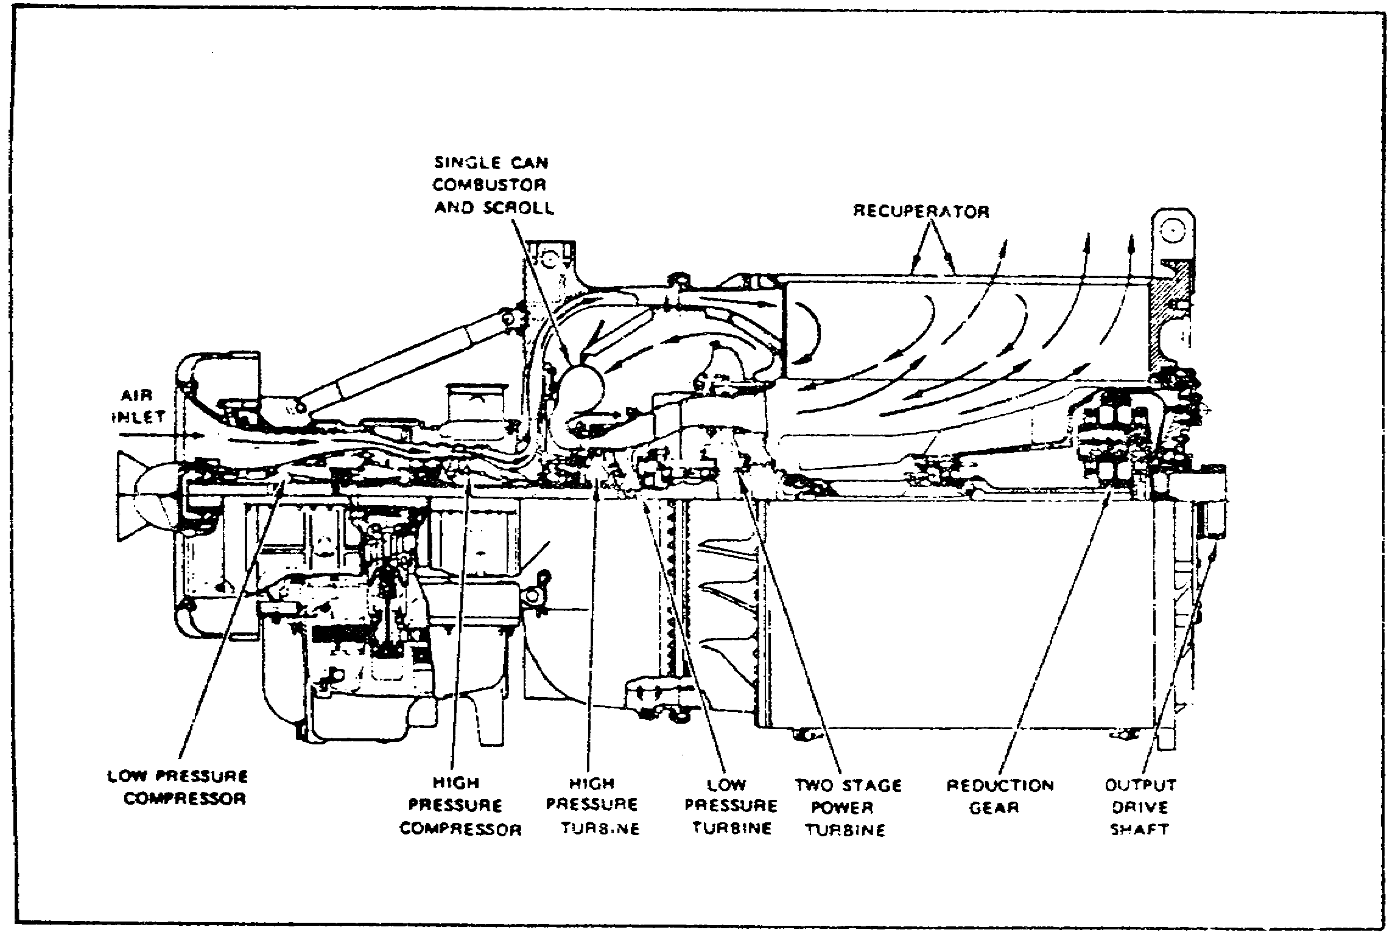

FIGURE 4. THE TURBINE ENGINE SYSTEM.

a. Air Control Components. Air supply for combustion is drawn from outside the tank by the action of the compressors. The air passes through a precleaner, filter elements, and a plenum duct to

7
PRINCIPLES & T/S M1 POWER TRAIN - OD 0478 - LESSON 1/TASK 2

the engine air inlet. From the inlet, the air flows through a low-pressure compressor section and then through a high-pressure compressor section. The compressed air then passes into a recuperator that is heated by the engine exhaust. The air heated in the recuperator then flows into the combustion chamber, where it mixes with fuel vapor and burns.

(1) Air Cleaner. Enemy fire is one of many situations that can raise a lot of dust. The air cleaner filters incoming air in two stages. The first stage filters remove most of the largest contaminants, using a vortex tube panel. The nonmetallic vortex tubes are treated with a fire retardant. The second stage filters remove the remaining contaminants, using barrier filters. These filters are made of pleated paper, treated with a fire retardant.

b. Fuel Control Components. The engine, and therefore the tank and its crew, is going nowhere without fuel. Fuel is fed from the vehicle fuel supply system to the engine fuel system. The engine electronic control unit controls the flow of fuel from the engine electromechanical fuel system (EMFS) to the combustion chamber. The engine electronic control unit and the EMFS automatically provide the correct fuel flow for varying engine operating conditions. Engine starting and operation are controlled by the EMFS. The EMFS meters fuel to the engine in response to the driver's controls. During unusual conditions, the EMFS automatically controls the engine's fuel flow and speed to protect the engine from damage. If the engine sensors fail, or the EMFS detects engine overspeed or overtemperature, the EMFS may limit engine performance, and the driver will experience some loss of engine power. EMFS problems are shown by the FUEL CONTROL FAULTY, the GAS OVERTEMP, and the OVERSPEED indicators on the driver's instrument panel (figure 5 on the
following page).

c. Combustion. The fuel must burn for the engine to produce the energy needed to move the tank. Electric ignition in the combustion chamber is used only during the starting cycle to start the burning process. After the start is completed, a continuous flow of air and fuel vapor maintains continuous burning, until either the air or the fuel flow is shut off. For normal engine shutdown,

8
PRINCIPLES & T/S M1 POWER TRAIN - OD 0478 - LESSON 1/TASK 2

the fuel flow is shut off. When air flow is decreased by clogged air filters (or for any other reason), increased burning temperature is sensed by the engine electronic control unit, which sends control signals to the EMFS. The EMFS reduces fuel flow to the combustion chamber. This reduces power output until adequate airflow is restored.

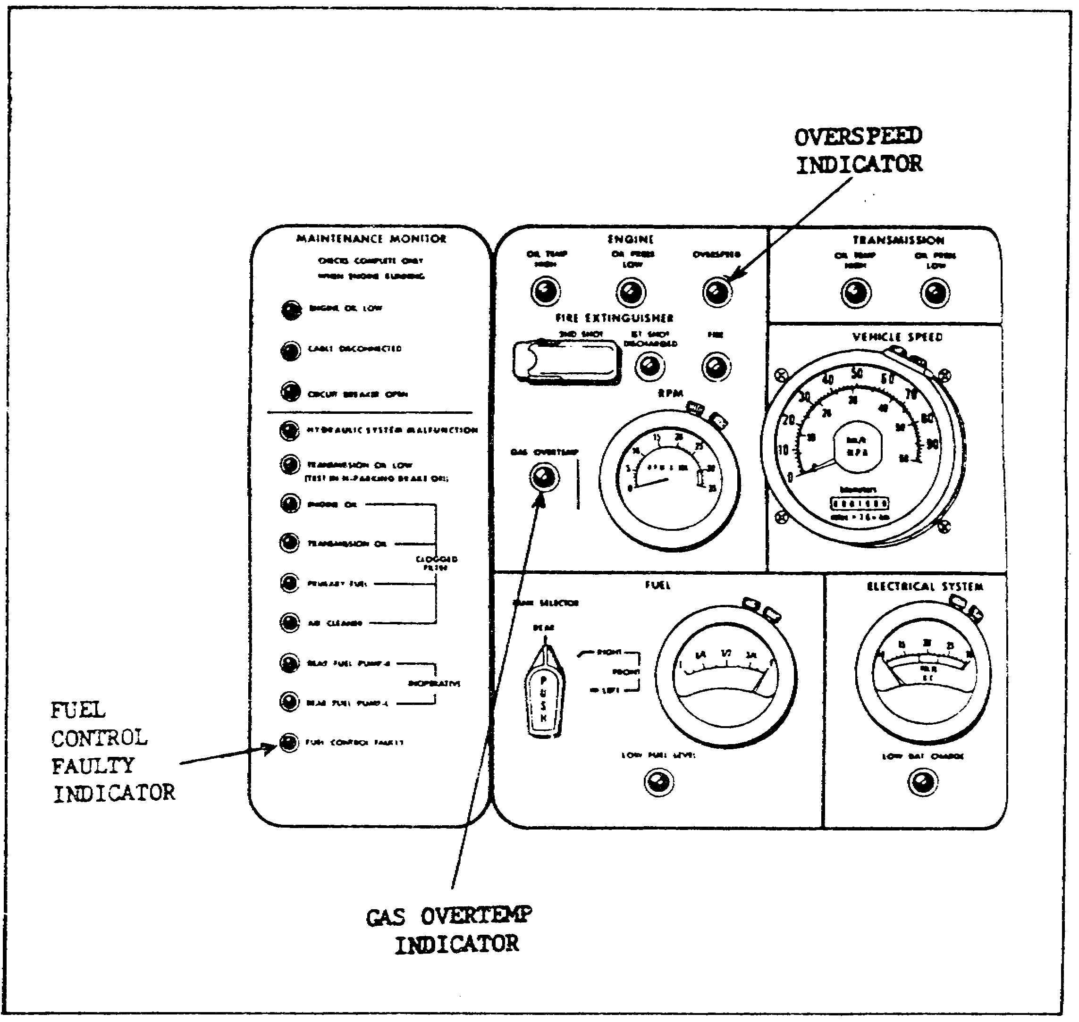

FIGURE 5. DRIVER'S INSTRUMENT PANEL.

d. Turbines. The turbines put to use the energy produced by the burning fuel. Exhaust gas leaves the combustion chamber through discharge nozzles and forces a two-stage turbine to turn. The high-pressure turbine drives the high –pressure compressor rotor. The low-pressure turbine drives the low-pressure compressor rotor. After leaving the low pressure turbine, the exhaust gas drives a

9

PRINCIPLES & T/S M1 POWER TRAIN - OD 0478 - LESSON 1/TASK 2

two-stage power turbine. The power turbine supplies the force to turn the engine power output drive shaft through a reduction gearbox.

e. Exhaust. Exhaust gas leaving the power turbine is routed around the recuperator and then into the exhaust duct. Heat from the exhaust gas helps heat the compressed air passing through the recuperator, to improve burning in the combustion chamber.

f. Engine Control. None of the features mentioned so far will do the crew any good unless the engine will reliably start and run. The starting and operation of the engine are controlled by the electronic control unit (ECU). The ECU automatically provides the proper fuel flow for starting, based on the engine temperature. This system management makes the engine start reliably under all operating conditions. The engine speed is controlled by twist grips on the steer-throttle control. Both twist grips turn in the same direction, and either can be used to control the engine speed. A higher (tactical) idle speed can be selected, by setting the TACTICAL IDLE switch on the driver's master panel to the ON position. This raises the idle speed from normal (870-950 rpm) to between 1250 and 1350 rpm.

(1) Starting the Engine. For the engine to start, the VEHICLE MASTER POWER switch and light, on the driver's master panel (figure 6 on the following page) must be ON. The driver pushes the START switch to begin the start sequence. When the START switch is pushed and released, it applies battery power to the starter, and to the ignition system. The START switch also starts both fuel pumps in the rear fuel tank. The starter turns the engine, and the ignition system produces a pulsating arc at the spark plug. The ECU senses the engine rotation and sends fuel and air to the engine. Within 60 seconds, the fuel ignites and the engine reaches a stabilized idle condition and is ready for vehicle movement at full power. When the electronic control system senses idle speed, it automatically turns off the starter and ignition. At the same time, the green STARTED light comes on. The STARTED light stays on for about 10 seconds, then goes out. The engine will keep running as long as the proper fuel and airflow are provided.

(2) Aborting the Start. The electronic control system automatically aborts a start if the engine

10
PRINCIPLES & T/S M1 POWER TRAIN - OD 0478 - LESSON 1/TASK 2

starting conditions are not right. The system will shut down the engine during a start if it senses overtemperature, overspeed, or low oil pressure conditions. The system will also abort a start if the engine fails to reach idle speed within about 45 seconds when the outside temperature is above freezing, or within about 60 seconds if the outside temperature is below freezing. The abort system turns off the starter and ignition and closes the main fuel shutoff valve. At the same time, it turns on the ABORT light.

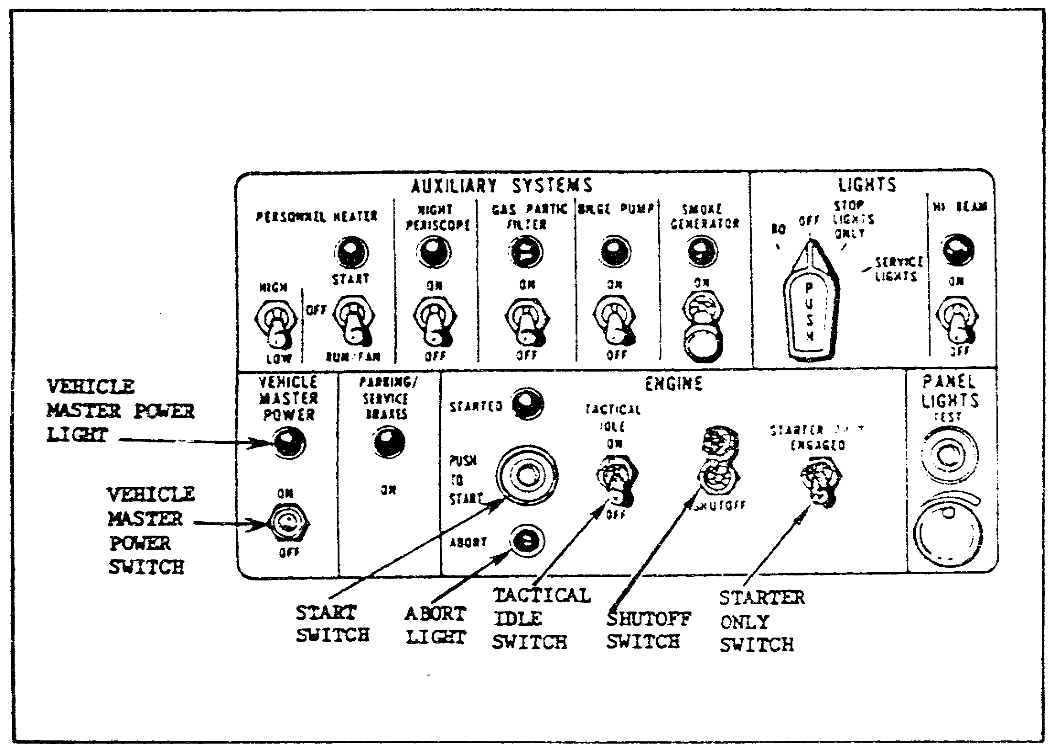

FIGURE 6. THE DRIVER'S MASTER PANEL.

(3) Engine Shut Down. The spring-loaded SHUTOFF switch is used to stop the engine. When this switch is moved down to the SHUTOFF position, the main fuel shutoff valve closes. This stops the flow of fuel to the engine. The engine should coast to a stop in 30 to 60 seconds.

(4) Engine Starter. When the STARTER ONLY switch is held in the ENGAGED position, the engine is rotated without the ignition or fuel pumps being turned on. This switch is used when the engine must be rotated but not started.

11
PRINCIPLES & T/S M1 POWER TRAIN - OD 0478 - LESSON 1/TASK 2

3. Transmission and Final Drives

No matter how much power the engine produces, the crew of the embattled M1 will still be sitting, unable to move, under enemy attack, unless the transmission and final drives are working properly. The transmission takes the power produced by the engine and sends it to the final drives. The final drives send the power to the tank tracks, so that the tank will move. A rear power takeoff is provided to drive the alternator. Two front power takeoffs are provided for driving the primary and auxiliary cooling fans. On the M1 tank, the transmission controls three tank functions: driving, steering, and braking.

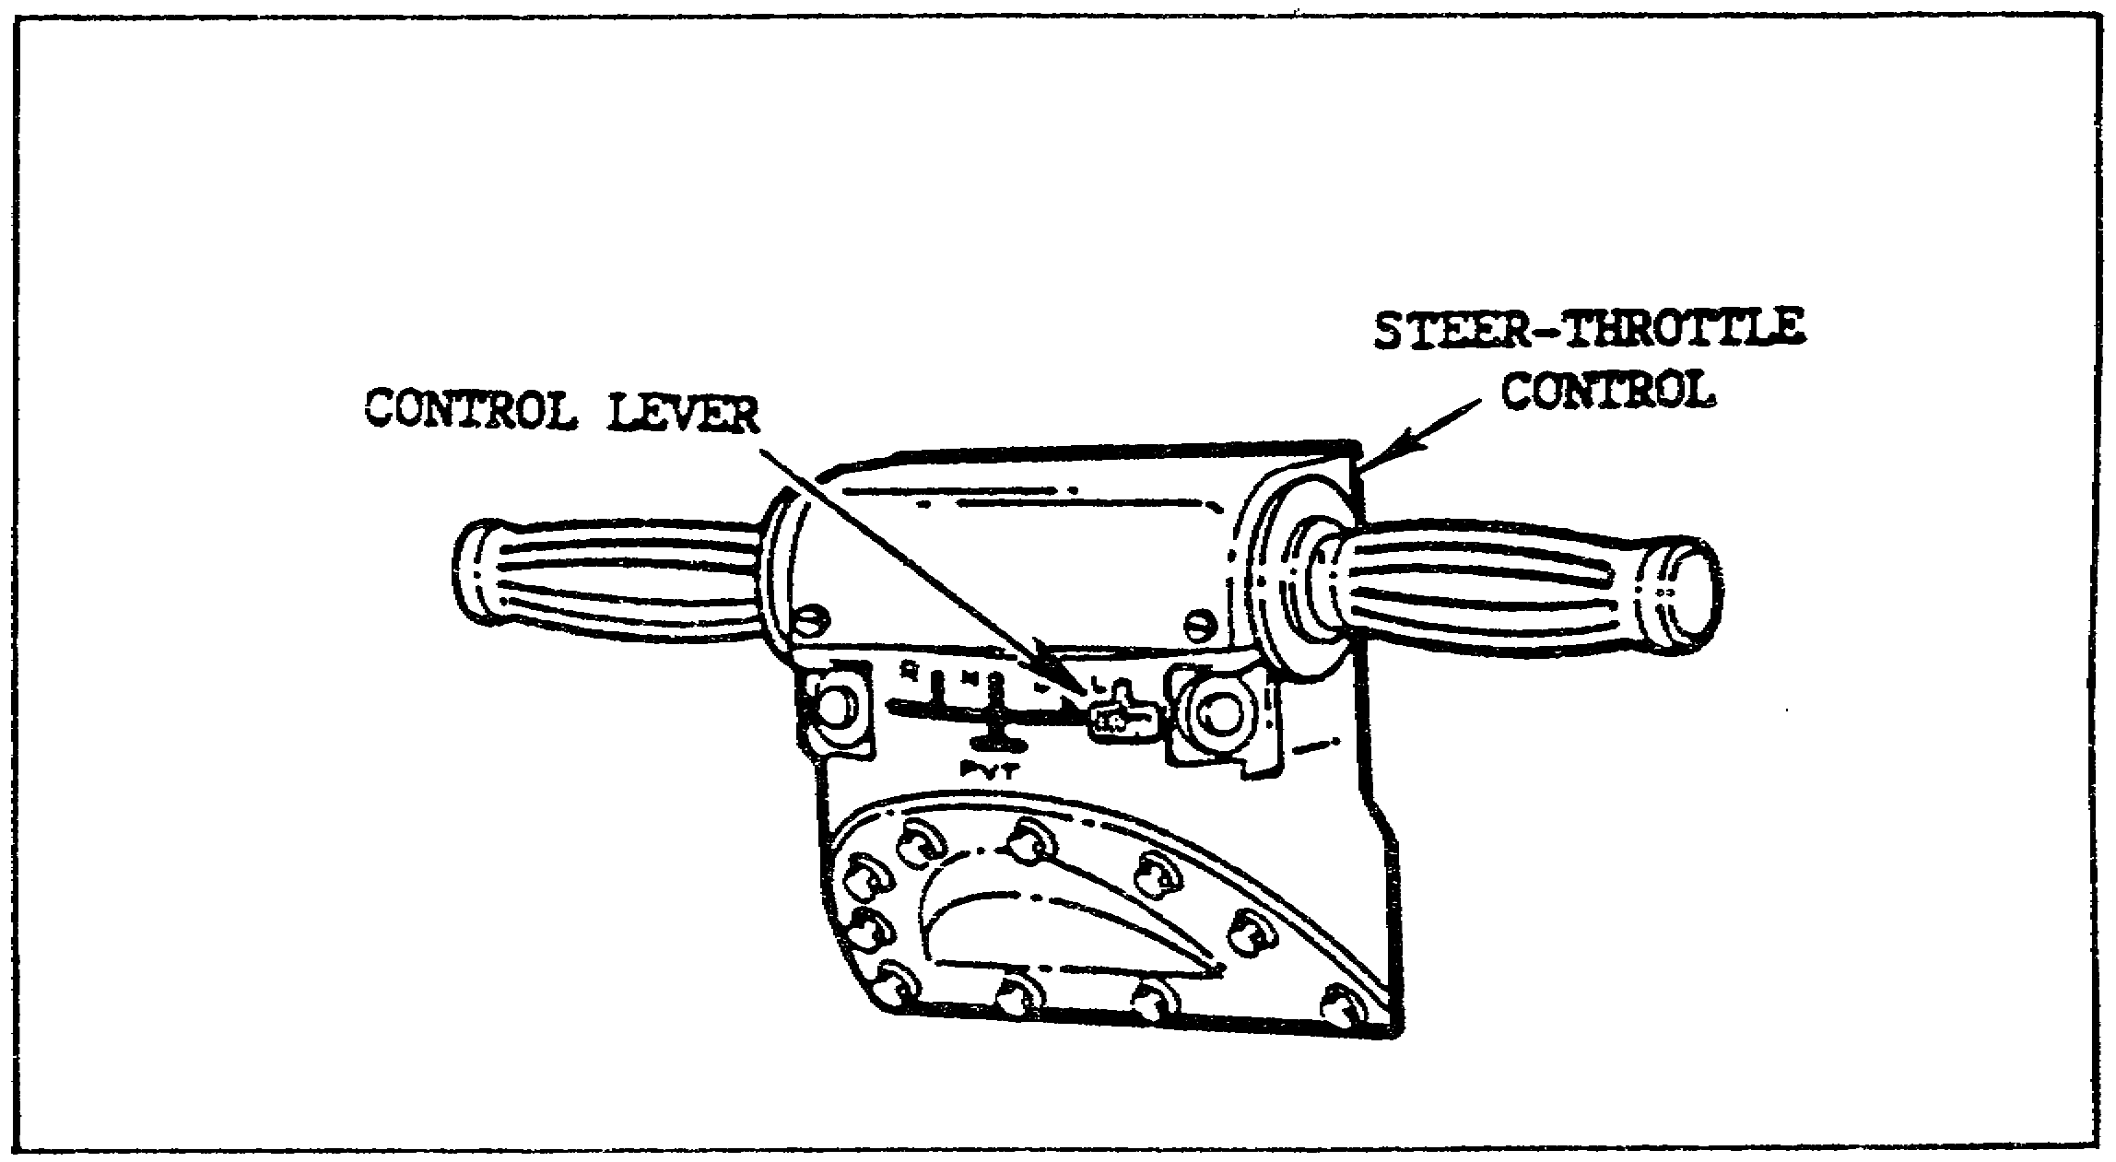

FIGURE 7. THE STEER-THROTTLE CONTROL.

a. Drive Function. Power from the transmission is transferred through the transmission's outputs to drive the sprockets. The transmission has four forward speeds and two reverse speeds, as well as a neutral position and a pivot condition. A control lever on the steer-throttle control (figure 7) electrically controls the transmission setting. The driver can set the transmission to D (normal forward drive range), L (low forward drive range), R (reverse), N (neutral), or PVT (pivot). In the D position, the transmission will start the track moving in the second forward gear and shift up automatically, as the speed and power requirements demand. The transmission will also shift back down

12

PRINCIPLES & T/S M1 POWER TRAIN - OD 0478 - LESSON 1/TASK 2

(to second gear), as needed. In the L position, the transmission starts the track moving in the lowest forward gear and shifts up, or back down, as needed. In the R position, the transmission starts the track moving in the lower reverse gear and shifts up, or back down, as needed. If the transmission control electrical power fails, the transmission continues to operate in the selected setting until the engine is shut down. When the engine is shut down, the control remains as selected, but the transmission automatically shifts to neutral.

b. Steering Function. The steering function is accomplished within the transmission. Steering commands come from the driver's steer-throttle control, which controls the direction of tank travel. With the control in its center position, the transmission powers both final drives equally and in the same direction. This causes the tank to move straight ahead. If the steer-throttle bar is moved, the transmission speeds up one final drive and track and slows down the other final drive and track, causing the tank to turn. The amount of speed difference between the final drives, and thus the degree of tank turning, depends on how far the steer-throttle bar is moved. No braking action is involved in steering the tank. If the engine fails while the tank is moving forward, steering remains effective until the speed drops to about 5 kilometers per hour (3 mph). When pivot (PVT) is selected, the transmission drives one track forward and the other in reverse, causing the track to turn about its center point.

WARNING

Do not move the steer-throttle control when the transmission control is set to N (neutral). Do not set the transmission control to N when the tank is moving. The tank will pivot steer, if the steer control is moved. This could cause the tank to wreck and possibly injure crew members. Do not attempt to pivot the tank with the transmission control set to N. Damage to the drive train can result, and personnel could be injured.

13

PRINCIPLES & T/S M1 POWER TRAIN - OD 0478 - LESSON 1/TASK 2

c. Braking Function. Braking the tank is done at each transmission output. The brakes are enclosed within the transmission output housing. Each brake pack has fourteen plates that are anchored to the transmission and remain stationary. Between these plates are thirteen plates that rotate with the transmission outputs. When the plates are squeezed together, the output coupling is slowed or stopped. Figure 8 shows a diagram of brake system connections.

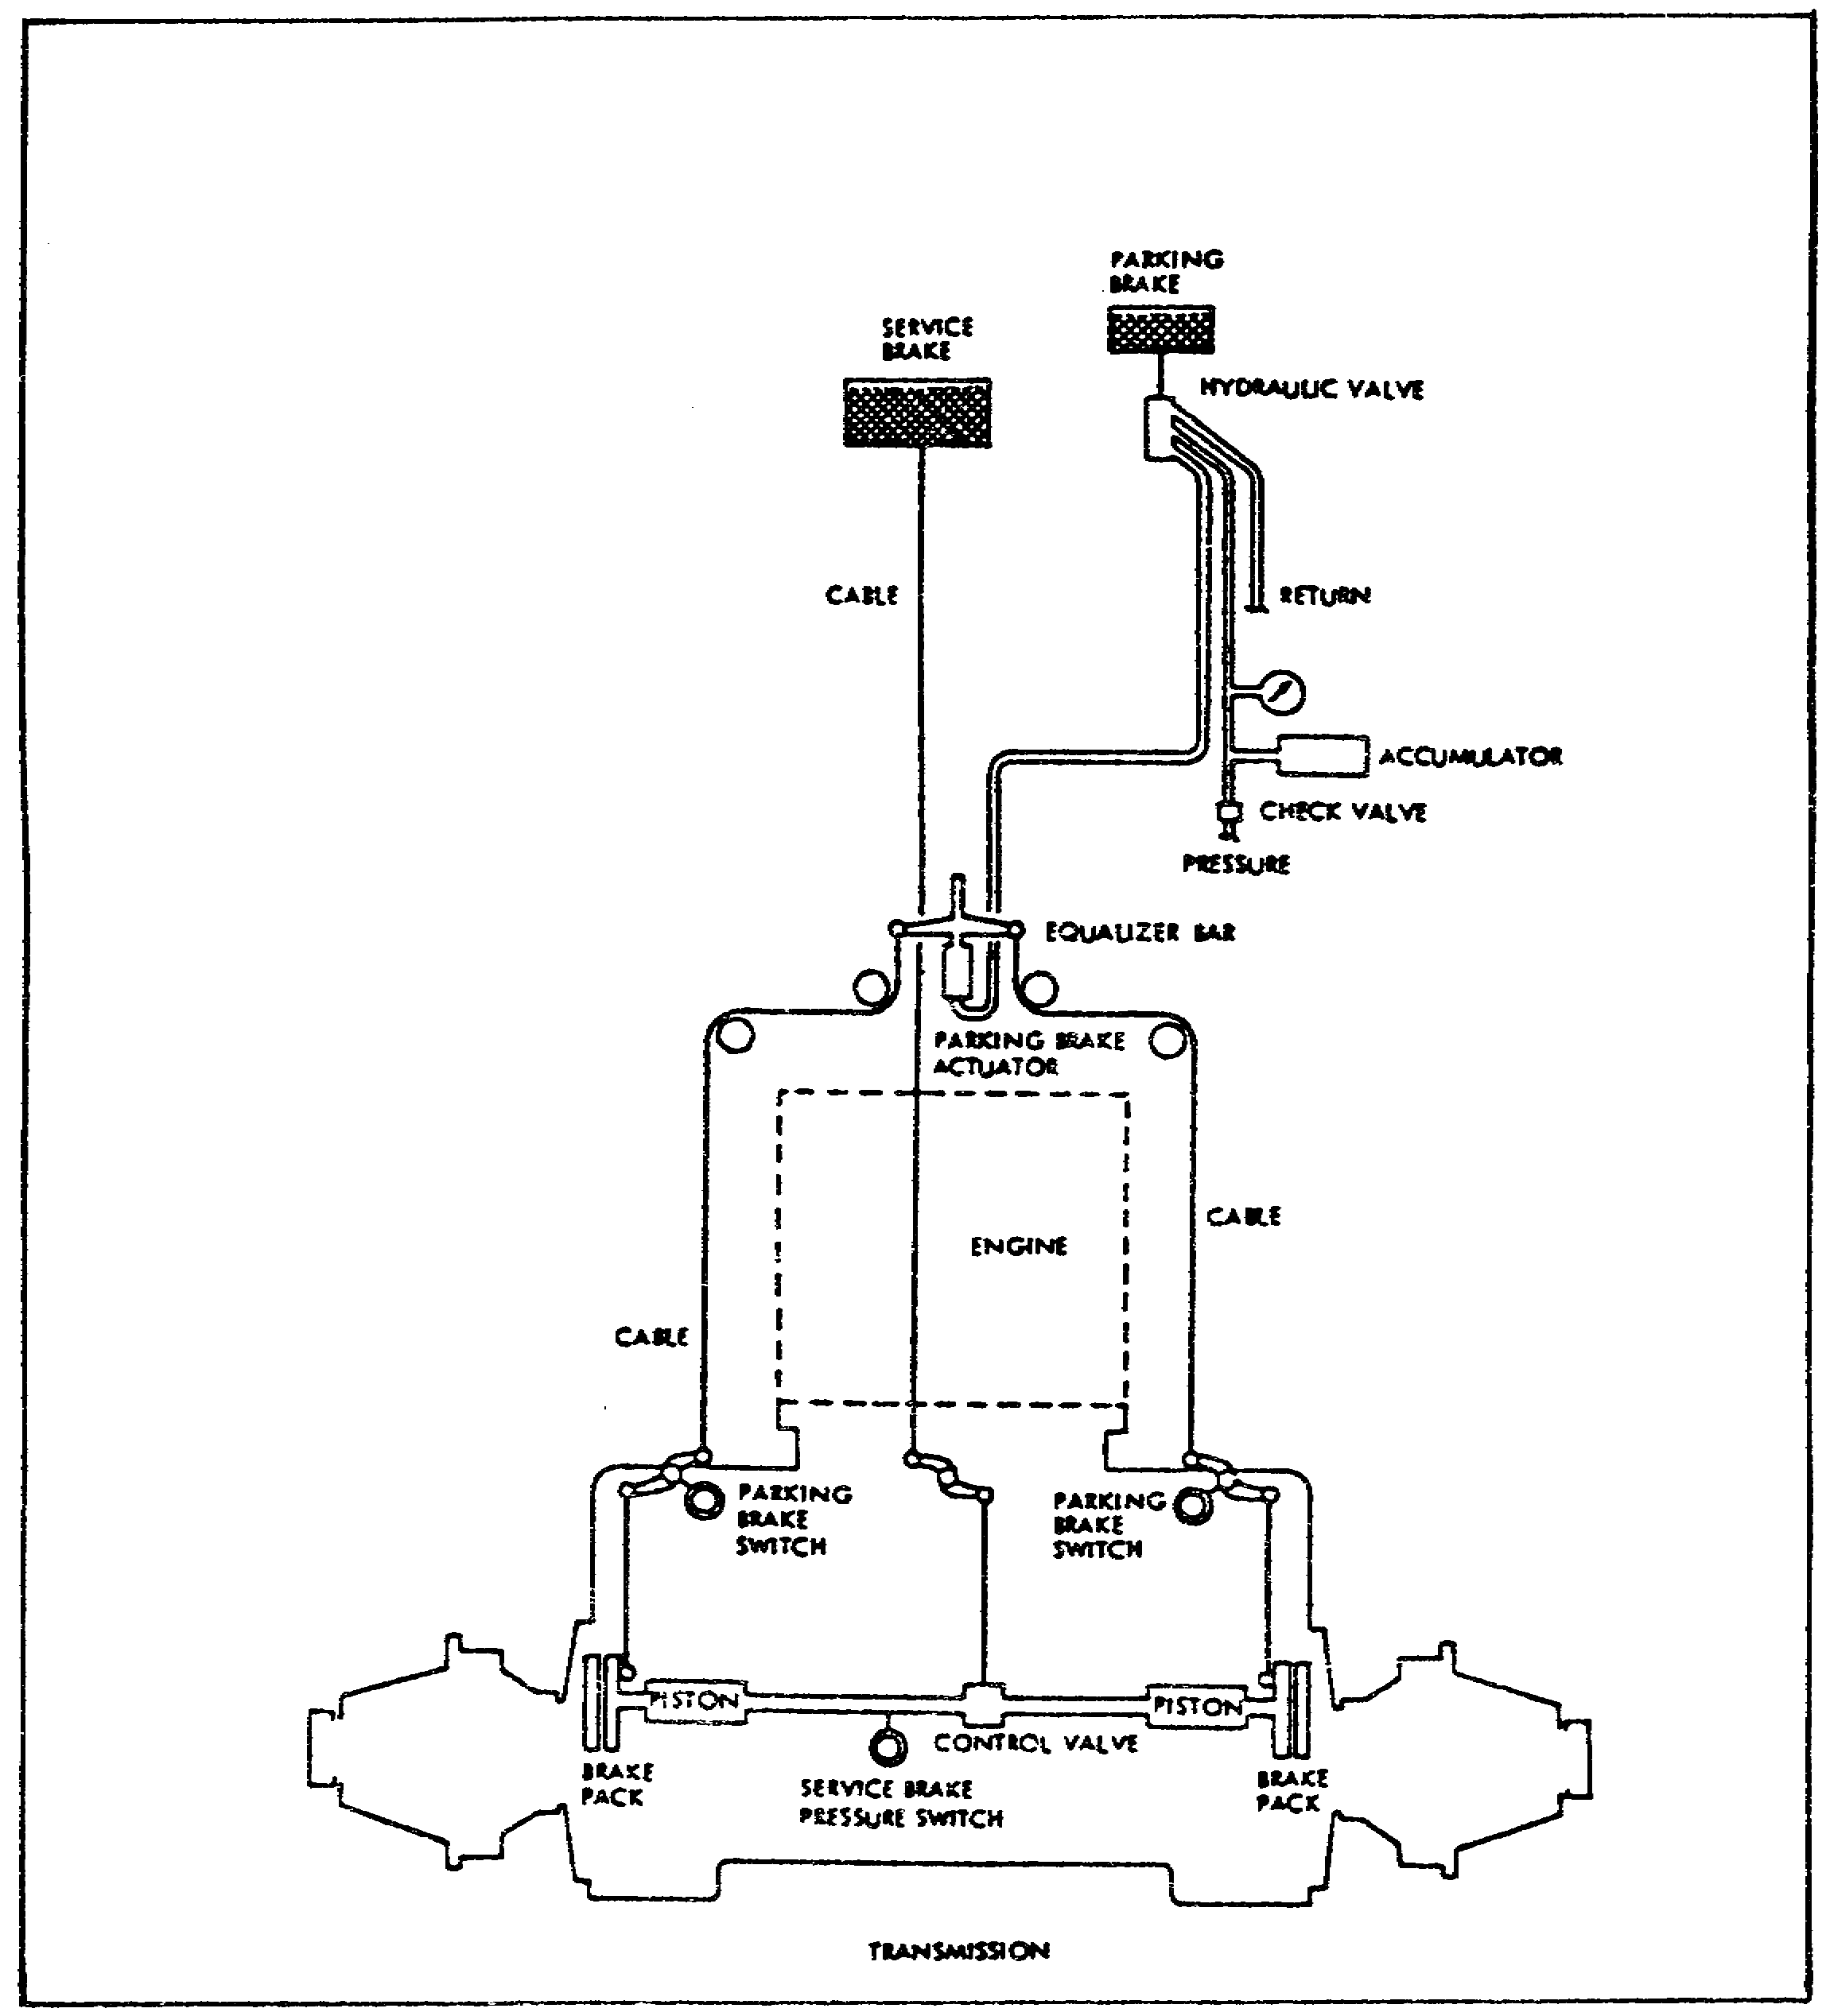

FIGURE 8. DIAGRAM OF THE BRAKE SYSTEM CONNECTIONS.

14

PRINCIPLES & T/S M1 POWER TRAIN - OD 0478 - LESSON 1/TASK 2

(1) Service Brakes. A cable from the service brake pedal is mechanically connected to a shaft on the transmission. Pressure on the pedal turns the shaft to open a valve causing hydraulic pistons to apply pressure to squeeze the rotating and stationary plates together. When the engine is not running, the service brakes will slow the tank. Without the power boost, the service brakes require more pressure on the service brake pedal. A red warning light on the driver's master panel will come on if the service brakes are applied for more than two minutes with the engine running.

(2) Parking Brake. The parking brake must be used to keep the tank from moving when it is parked. The N (neutral) setting on the transmission does not lock the transmission. The parking brake system consists of a foot pedal, a hydraulic valve, an accumulator, an actuator equalizer bar, and a ratchet release handle. Pressure on the parking brake pedal sends hydraulic pressure to the actuator in the turret well. The actuator is connected to an equalizer bar which is moved away from the actuator by the hydraulic pressure. The equalizer bar has two cables connected to it which are pulled equally as the equalizer bar moves away from the actuator. These cables are mechanically linked to the same sets of rotating and stationary plates that are used for service braking. The accumulator maintains enough hydraulic pressure for four or five pushes on the parking brake pedal after the engine has shut down. A warning light on the driver's master panel will come on if the parking brake is on while the engine is running.

d. Oil Coolers. The engine and transmission oil cooling systems keep the oil temperatures within acceptable limits under all operating conditions. The primary cooling system has a fan, a fan drive system, a cooling duct, an engine oil cooler, and a transmission oil cooler. When the engine is running, the fan drive turns the primary fan, to provide airflow to the primary oil coolers. The auxiliary oil cooling system has a fan, a fan drive system, a cooling duct, and a transmission oil cooler. If the transmission oil temperature exceeds the cooling capacity of the primary cooling system, an electrically controlled clutch automatically engages the auxiliary cooling fan. The auxiliary cooling fan disengages during fording operations. The transmission oil flows through the

15

PRINCIPLES & T/S M1 POWER TRAIN - OD 0478 - LESSON 1/TASK 2

primary and auxiliary coolers. An oil filter in the transmission prevents dirt from entering the transmission mechanism. A pressure sensor downstream from the filter senses a drop in oil pressure when the filter becomes clogged. The sensor lights the TRANSMISSION OIL FILTER CLOGGED caution light on the driver's instrument panel.

e. Final Drives. The final drives are heavy-duty speed-reduction gear assemblies that make the final connection from the transmission outputs to the tank's right and left tracks. The final drives are identical. The track drive sprockets are bolted to the final drive output shafts. The final drives step down the transmission output speed and step up the torque. The final drives are built so that the coupling between the-tracks and the transmission can be disconnected. When the couplings are disconnected, the tank can be towed without turning the transmission outputs.

4. Conclusion

When all of these power train components are operating properly, the crew of the M1 tank can drive, steer, brake, and maneuver with considerable agility and power. Occasionally, however, a failure in the system causes problems. If the cause of the failure is not obvious, troubleshooting procedures must be performed to isolate the malfunctioning component. Lesson 2 will describe the procedures for troubleshooting the M1 power train.

16

PRINCIPLES & T/S M1 POWER TRAIN - OD 0478 - LESSON 1/PE 1

PRACTICAL EXERCISE 1

1. Instructions

Read the scenario and respond to the requirements that follow the scenario.

2. Scenario

It is a beautiful spring day. The post to which you are currently assigned is having an open house. Displays have been set up for most of the equipment on post. You are lucky enough not to have been assigned to any of the displays; and, since your grandfather is bringing your cousin down for the open house, you have been given permission to personally show them around the shop. Your grandfather is a veteran who used to work on the old M48 tanks, and your cousin is currently in the M1 residence course at a neighboring post. Both of them will be very interested in the knowledge you have gained as an M1 Abrams tank system mechanic.

First Requirement

It turns out that your grandfather has seen some films of the M1 in action, and is most interested in how the power train operates. Fill in the blanks in the paragraph below that explains the principles of operation of the M1 power train.

The M1 power train has a a. engine mated to a/an b.
transmission. The engine provides power to the transmission, and thus to the c. so that the vehicle can be moved. Air entering the engine flows through two compressors and then is heated by the d. to help in burning. Air is then directed into the e. where it mixes with fuel vapor. Burning is started with an ignition spark. The engine drives the transmission through a reduction gearbox. The M1 transmission performs three functions: f. , g. , and h. . Transmission ranges are selected by energizing i. in the transmission. The
j. is the method by which the driver controls the direction of tank travel. The k. connect the transmission outputs to the tracks. They step down the transmission output and step up the l.

17

PRINCIPLES & T/S M1 POWER TRAIN - OD 0478 - LESSON 1/PE 1

Second Requirement

Your grandfather wants more technical information. Briefly answer these questions.

a. How is the fuel flow controlled?

b. Describe the starting sequence.

c. Describe the method used within the transmission for steering the tank.

18

PRINCIPLES & T/S M1 POWER TRAIN - OD 0478 - LESSON 1/PE 1

LESSON 1. PRACTICAL EXERCISE - ANSWERS

First Requirement

a. Turbine

b. Automatic

c. Final drives

d. Exhaust gases

e. Combustion chamber

f., g., and h. Driving, steering and braking

i. Solenoid valves

j. Steer-throttle control

k. Final drives

l. Torque

Second Requirement

a. The engine electronic control unit and the engine electromechanical fuel system (EMFS) automatically provide the correct fuel flow to the engine. The EMFS meters fuel to the engine in response to driver controls. In unusual conditions, the ECU controls the fuel flow and engine speed, to protect the engine from damage.

b. With the VEHICLE MASTER POWER switch and light ON, the START switch is pushed. The switch sends battery power to the starter and ignition system, and starts both fuel pumps. The starter turns the engine, and the ignition system produces an arc at the spark plug. The ECU senses engine rotation and sends fuel and air to the engine. The fuel ignites, and the engine reaches idle speed.

c. Steering in the transmission depends on the position of the steer-throttle control. With the control in the center position, the transmission powers both final drives equally, so the tank goes straight. When the control is moved, the transmission speeds up one final drive and slows down the other, causing the tank to turn.

19

PRINCIPLES & T/S M1 POWER TRAIN - OD 0478 - LESSON 2/TASK 1

LESSON 2

MALFUNCTIONS AND TROUBLESHOOTING PROCEDURES
FOR THE POWER TRAIN ON THE M1 TANK

TASK 1. Describe the procedures to be used in troubleshooting and isolating malfunctions of the power train on the M1 tank.

CONDITIONS

Within a self-study environment and given the subcourse text, without assistance.

STANDARDS

Within two hours

REFERENCES

No supplementary references are needed for this task.

1. Introduction

When equipment malfunctions, the cause of the problem is not always obvious. Knowing how to isolate the faulty component is an essential part of materiel maintenance. The step-by-step process of finding the component(s) causing the problems is called troubleshooting. In the general sense, troubleshooting is a logical thought process. When applied methodically, this process leads to the identification of defective parts so that the malfunction in the tank can be repaired.

This lesson deals with the methods used in troubleshooting the power train components on the M1 tank. Therefore, this lesson will use a single malfunction symptom as an example. The sample malfunction symptom that will be used in this lesson is: NO STEERING CONTROL. It is important to remember that this symptom is being used as a sample only. Step-by-step troubleshooting

20

PRINCIPLES & T/S M1 POWER TRAIN - OD 0478 - LESSON 2/TASK 1

procedures will vary from malfunction to malfunction, but the methods used in this sample task will serve as a general guideline for other troubleshooting tasks.

2. Troubleshooting Methods for the M1 Power Train

Troubleshooting is a three step process. The first step involves correctly identifying the symptom. The second step is to find the right procedure for troubleshooting that symptom in the appropriate technical manual (TM) and to then use the step-by-step troubleshooting flow charts in the TM to isolate the malfunctioning component. Step three involves replacing or repairing the component, and verifying that the problem has been solved.

a. Identifying the Symptom. The first source of information about the malfunction symptom comes from the DA Form 2404 that was filled out by the crew. Using the sample symptom NO STEERING CONTROL, the information on the DA Form 2404 might be entirely adequate. However, if the description on the DA Form 2404 reads something like, "Tank doesn't steer correctly," a number of steering system symptoms might fit. Therefore, when not enough information is given on the DA Form 2404 to accurately identify the symptom, it may be necessary to talk to the crew members to get as much information about the symptom as possible. For some symptom descriptions, it may also be necessary to operate the tank to help identify the specific symptom.

WARNING

Do not try to operate the tank if there is any chance that the symptom may injure personnel or damage the tank. Example: NO STEERING CONTROL.

b. Locating the Troubleshooting Procedure. Once the symptom has been identified, it is necessary to locate the step-by-step procedures in the appropriate TM, so that the component causing the problem can be found and repaired or replaced. The first step in this process is to locate in the TM the system or subsystem under which the symptom is listed.

21

PRINCIPLES & T/S M1 POWER TRAIN - OD 0478 - LESSON 2/TASK 1

NOTE

All of the troubleshooting indexes and procedures necessary for troubleshooting the power train systems and subsystems on the M1 tank are located in TM 9-2350-255-20-1-2-1. UNLESS OTHERWISE STATED, ALL REFERENCES TO THE TM IN THIS LESSON REFER TO TM 9-2350-255-20-1-2-1.

(1) Troubleshooting Index. The troubleshooting index located in chapter three of the TM is the master reference table for locating the troubleshooting information for a particular system. It lists each group or system, and provides a reference, by figure number, to the troubleshooting information for that system.

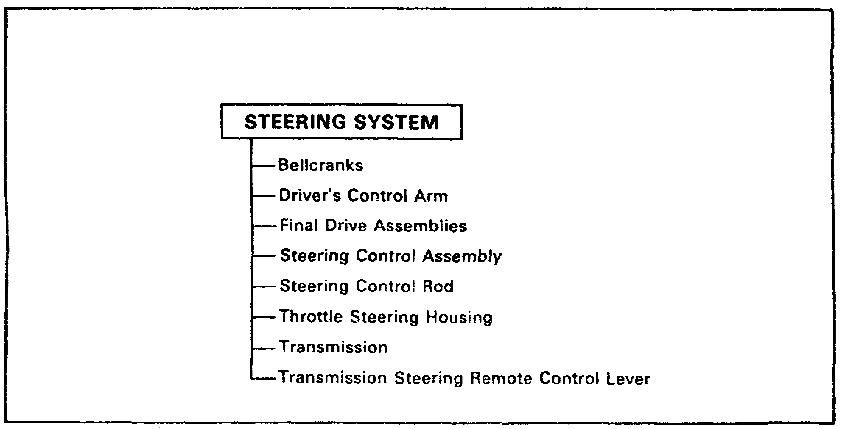

FIGURE 9. A TROUBLESHOOTING ROADMAP.

(2) Troubleshooting Roadmaps (see sample shown in figure 9). Troubleshooting roadmaps, sometimes called troubleshooting charts, are provided in the TM for each functional system. These troubleshooting charts give an overall view of the assemblies or parts included in each system. The roadmaps are organized by system, and list the components that can be replaced in the troubleshooting procedures. These charts can be useful when the mechanic has an idea of what component has failed, but is having difficulty in identifying the system or subsystem under which the symptom is listed. By finding the suspect

22
PRINCIPLES & T/S M1 POWER TRAIN - OD 0478 - LESSON 2/TASK 1

component in the charts, the system containing the component can often be identified.

(3) Fault Symptom Indexes. Symptoms in the TM are identified by Fault Symptoms Indexes. Separate Fault Symptom Indexes are provided for each functional group or system. A listing of the indexes by system can be found as the first table in the TM chapter devoted to Fault Symptom Indexes. This table provides the table numbers and page numbers where the individual system Fault Symptom Indexes can be found. Each system table lists the fault symptoms for that system or subsystem and refers to the TM and paragraph where the troubleshooting procedures for that system can be found. Sometimes the symptom description on the DA Form 2404 may not be exactly as described in the indexes. If the description closely resembles one that is listed in the indexes, use the troubleshooting procedures referenced for that symptom. However, if the symptom simply cannot be found in the indexes, the supervisor should be informed so that IDS maintenance can be notified.

In the case of the sample task NO STEERING CONTROL, the system is evident. The Fault Symptom Index for the steering subsystem should be used. Table 1, on the following page, shows the Steering System Fault Symptom Index. The sample symptom, No Steering Control, is listed first in the table. The first column of table 1 provides the system fault symptom number. Column two describes the symptom. The third column lists the TM and paragraph where the primary troubleshooting procedures (PTP) can be found. In the sample case, since the PTP are in the same manual as the table, only the appropriate TM paragraph number is listed. The last column lists the resources that will be needed to perform the task. In the case of the sample symptom, NO STEERING CONTROL, the simplified test equipment (STE) will not be needed. However, two people will be needed to complete the job. When actually performing the troubleshooting procedures, it will be necessary to get the TM listed in the table and find the paragraph number where the troubleshooting procedures are detailed. For the purposes of this subcourse, however, the TM will not be needed, since all the TM information required for the sample troubleshooting task will be provided in the subcourse.

23

PRINCIPLES & T/S M1 POWER TRAIN - OD 0478 - LESSON 2/TASK 1

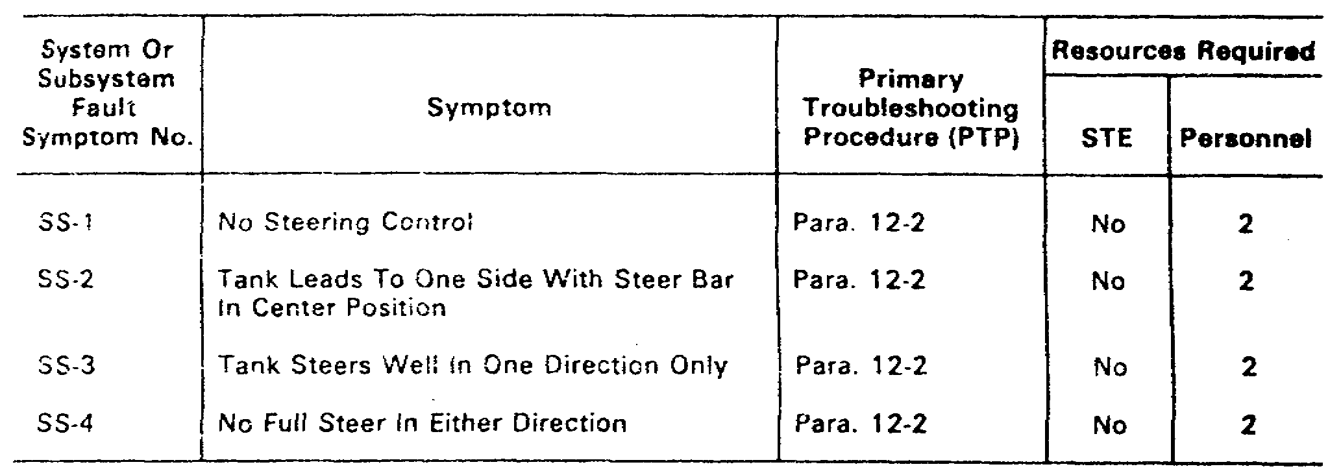

TABLE 1. STEERING SYSTEM FAULT SYMPTOM INDEX.

(4) System or Subsystem Fault Symptom Index. The information gained from table 1 leads to the System or Subsystem Fault Symptom Index, at the beginning of the troubleshooting procedures in the TM for the system that is having problems. Table 2, on the following page, is the Fault Symptom Index found at the beginning of the troubleshooting procedures for the steering system. Again, the sample symptom is the first listed in the table. Column 1 provides the fault symptom number. The third column gives the figure number in the TM where the specific primary troubleshooting procedures for the identified symptom can be found. The Troubleshooting Procedures Fault Symptom Index for the steering system is straightforward, since the simplified test equipment for the M1 (STE-M1) will not be needed for any of the symptom procedures. The Troubleshooting Procedures Fault Symptom Index for a system or subsystem that requires the use of the STE-M1, such as the transmission shift subsystem, contains two additional columns. The first of these columns identifies the test number to be entered into the STE-M1 during the troubleshooting procedures for that symptom. The second additional column locates the TM and figure number where the alternate troubleshooting procedures can be found.

c. Troubleshooting Procedures. Once the troubleshooting procedures have been located in the TM, troubleshooting can begin. The troubleshooting procedures appear in the TM in the form of fault isolation flowcharts. Each flowchart begins with a fault symptom that can be seen, felt, or heard during operation of the tank, without using test equipment. Step-by-step instructions for finding

24

PRINCIPLES & T/S M1 POWER TRAIN - OD 0478 - LESSON 2/TASK 1

and correcting the fault are given for each symptom. When needed, illustrations are included for the symptom, showing the locations of all the test points and how each troubleshooting step should be done. If the tank still has problems after a troubleshooting procedure has been performed and corrective action has been taken, the tank may have had more than one fault. When this is the case, it will be necessary to continue troubleshooting.

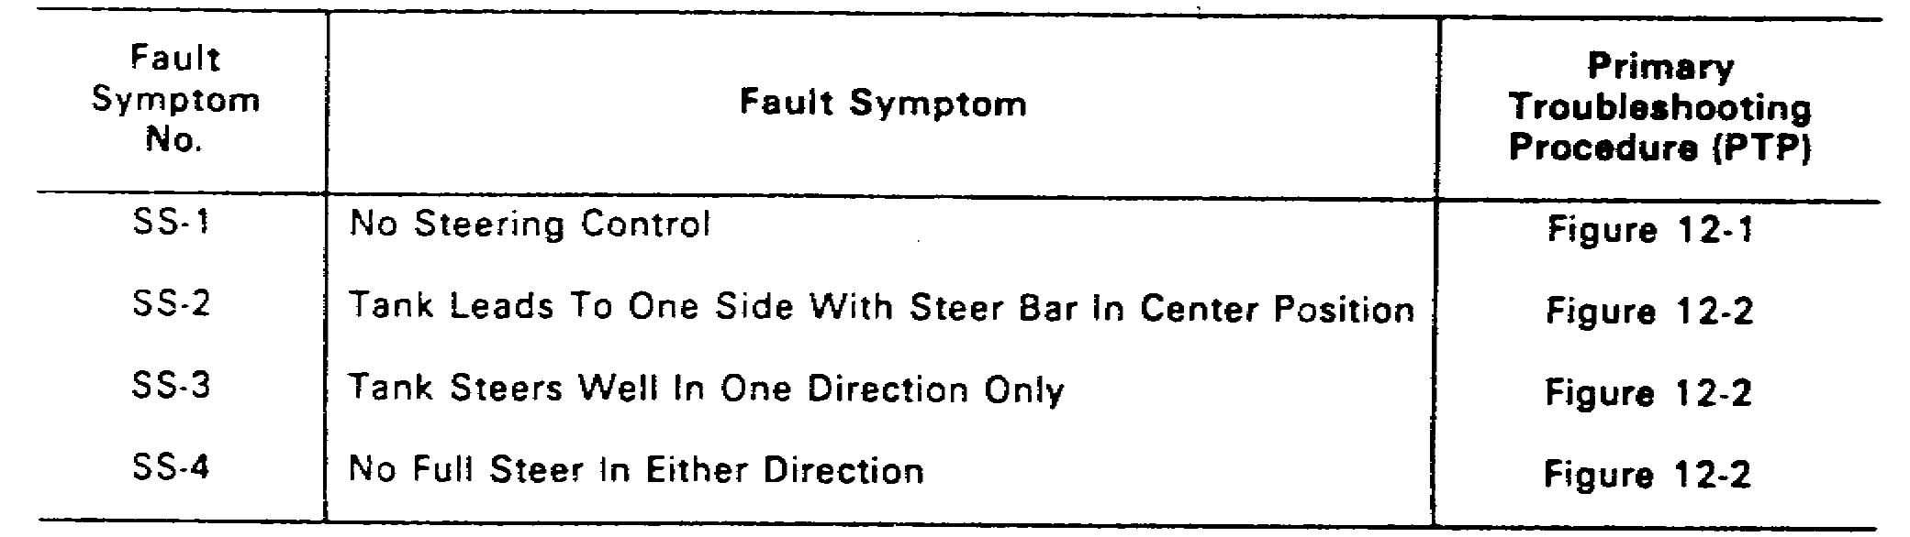

TABLE 2. STEERING SYSTEM TROUBLESHOOTING PROCEDURES FAULT SYMPTOM INDEX.

d. Alternate Troubleshooting Procedures. Alternate troubleshooting procedures are also included in the TM. At the unit maintenance level, the alternate troubleshooting procedures are provided for use when the STE is not available. Since the symptom being used as an example in this subcourse does not use the STE, no alternate troubleshooting procedures are provided for the symptom.

e. Test Equipment Procedures Index. For those symptoms which require the use of the STE and other test equipment, a Test Equipment Procedures Index is provided in the TM. This index lists the test equipment used for troubleshooting and provides a reference, by figure number, to the detailed instructions for their use.

3. Troubleshooting a Power Train Fault Symptom

When the fault symptom has been identified and the troubleshooting procedures have been located in the

25

PRINCIPLES & T/S M1 POWER TRAIN - OD 0478 - LESSON 2/TASK 1

TM, the step-by-step fault isolation procedures can begin.

a. Preparing to Troubleshoot. At the very beginning of the Fault Isolation Flow Chart in the TM, a list is provided detailing the common tools, supplies, special tools and test equipment, and equipment condition necessary to perform the procedure. Everything needed to accomplish the task should be gathered before beginning the step-by-step procedures. If the troubleshooting procedure for the fault symptom, NO STEERING CONTROL, were actually to be performed, the following would be needed:

(1) Common Tools. The common tools needed to troubleshoot this symptom are:

(a) A 1/2 inch square drive, 10 inch extension socket wrench.

(b) A 1/2 inch square drive socket wrench handle.

(c) Long, round nose pliers.

(2) Supplies. A cotter pin and a 13 millimeter socket will be needed when performing the step-by-step procedures.

(3) Special Tools. Retaining ring external pliers are the only special tool needed for this task.

(4) Equipment Condition. Before beginning the troubleshooting procedures, the tank must be parked in an area where it is safe to traverse the turret. The parking brake must be set and the tracks blocked front and rear. The engine must be shut down and the VEHICLE MASTER POWER should be OFF.

(5) Personnel. Two people are needed to complete the sample troubleshooting task. The first person is responsible for performing the job. The second person takes directions from the first.

b. Troubleshooting the Symptom. As was mentioned earlier, this subcourse will use the fault symptom, NO STEERING CONTROL, as an example, to give a general idea of how a troubleshooting procedure for the M1 power train is performed. Since this subcourse deals with troubleshooting, the repair or

26

PRINCIPLES & T/S M1 POWER TRAIN - OD 0478 - LESSON 2/TASK 1

replacement procedures to be performed, once the defective component has been found, will not be presented here. Instead, reference will be made to the TM in which the repair/replacement procedure can be found, if needed.

The fault isolation flowcharts in the TM move step-by-step through the troubleshooting procedures. Generally, an action is required and then a yes or no question is asked. The next action depends on the yes or no response. This approach to troubleshooting tends to divide the troubleshooting task into major pathways. For the symptom, NO STEERING CONTROL, two initial tests are performed. The results of these two tests develop three major pathways in the flowcharts.

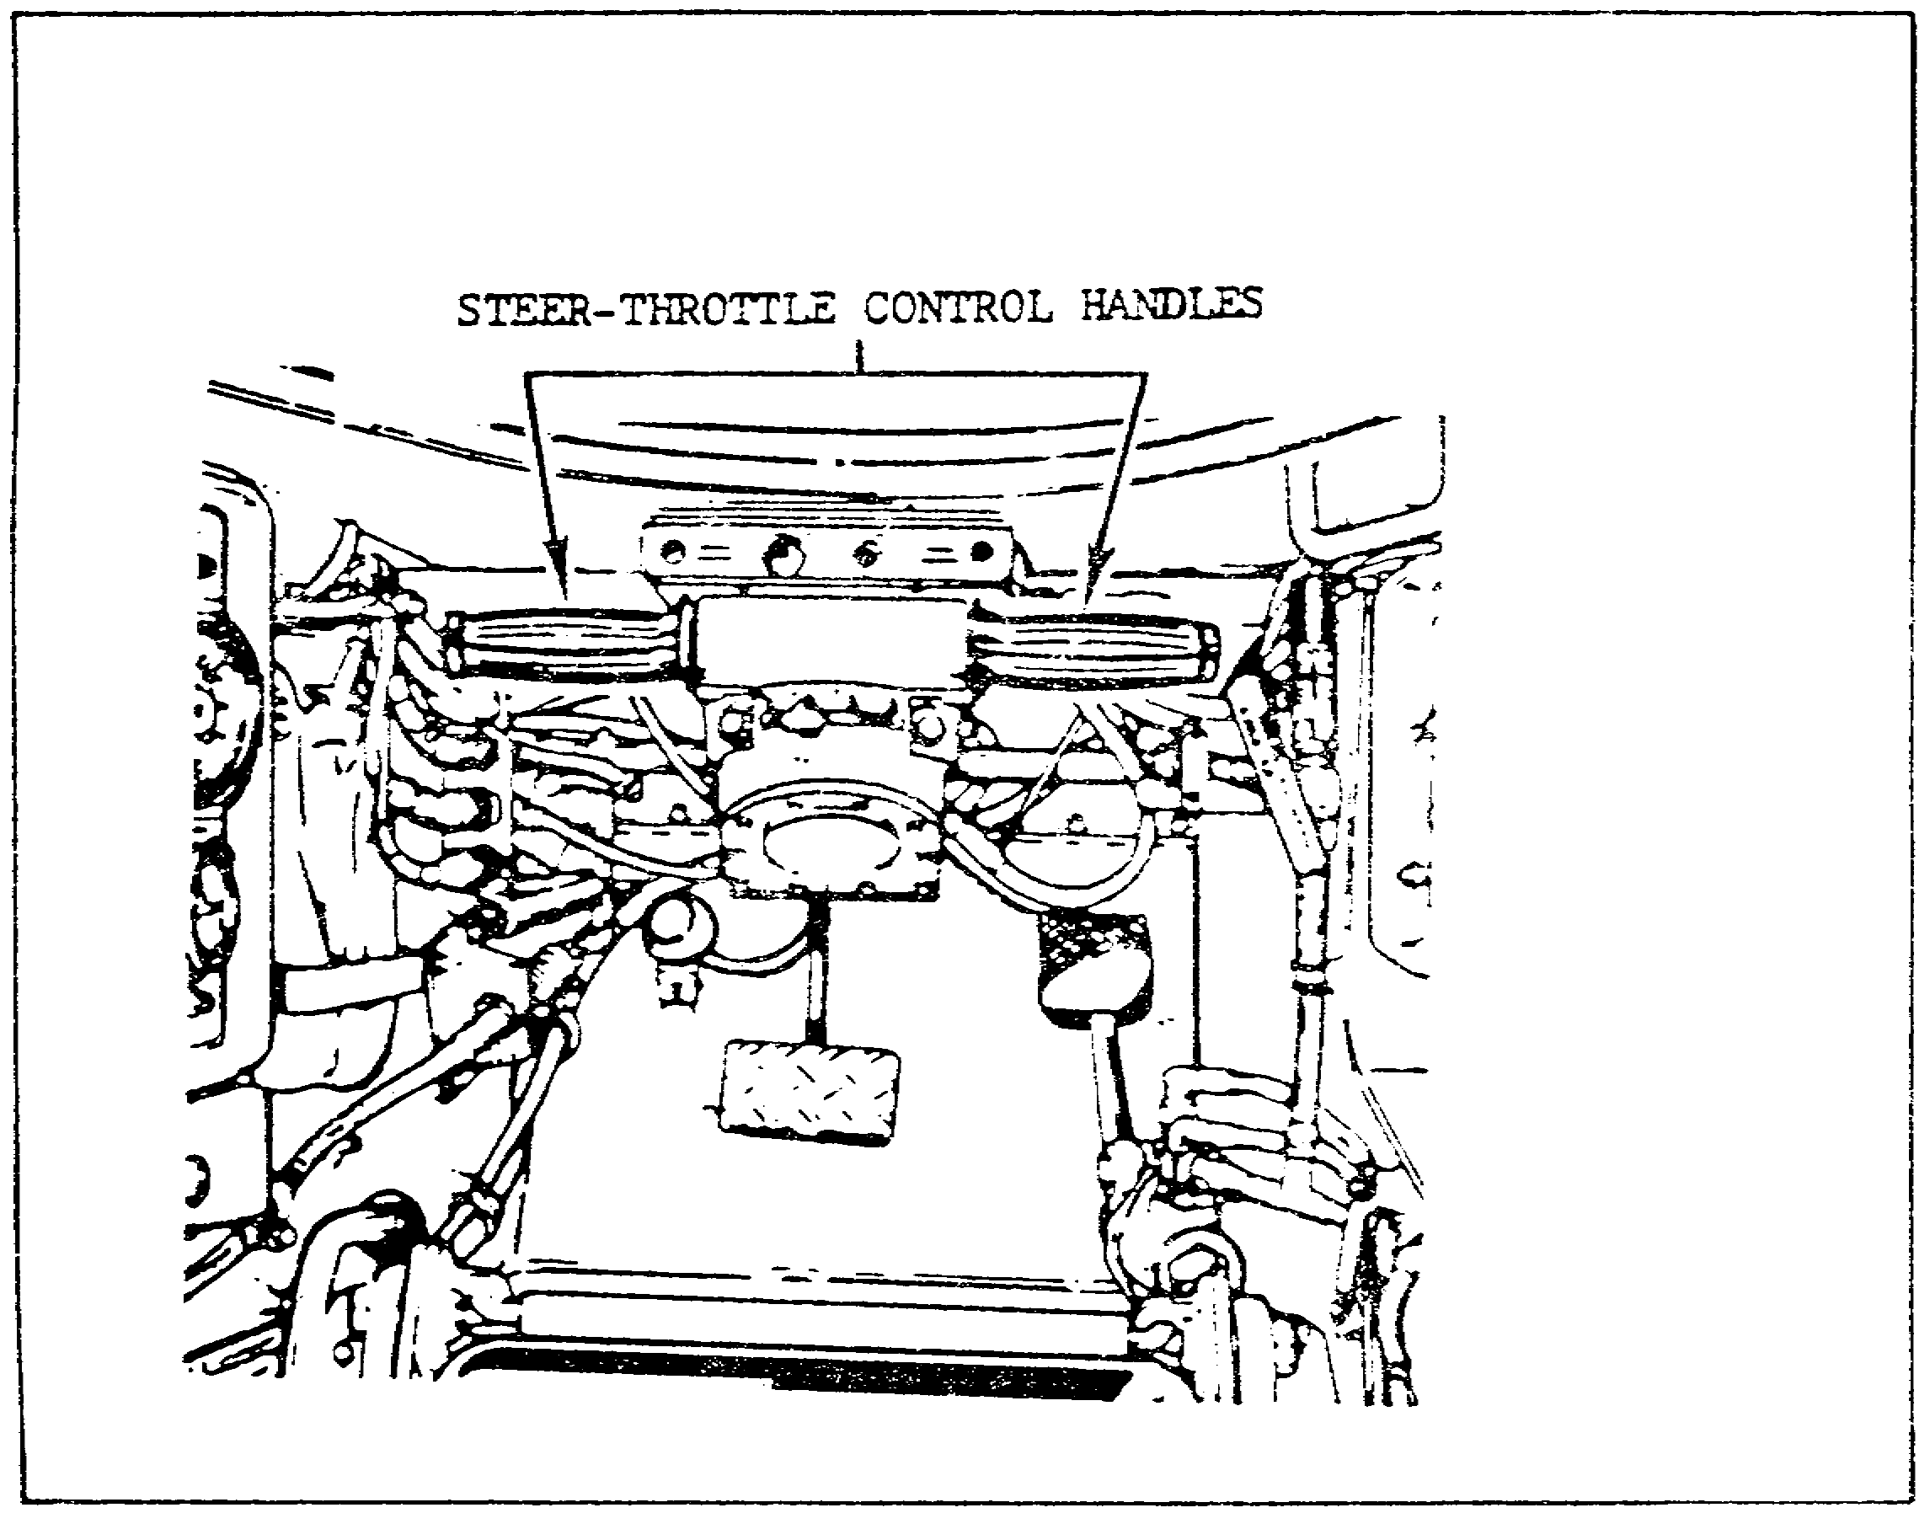

FIGURE 10. THE STEER-THROTTLE CONTROL HANDLES.

c. Initial Tests. The first action in the troubleshooting sequence for the malfunction, NO STEERING CONTROL, is to try to move the steer-throttle control handles (figure 10) fully to the right and then fully to the left. The next action

27
PRINCIPLES & T/S M1 POWER TRAIN - OD 0478 - LESSON 2/TASK 1

depends on whether the handles could be moved. If the handles could not be moved, the procedures described in troubleshooting pathway number one (in paragraph 3d on page 28) would be followed. If the handles will move, check to see if the lever (figure 11) moves and the shaft rotates on the transmission when the steer-throttle control is turned. To do this, proceed as follows:

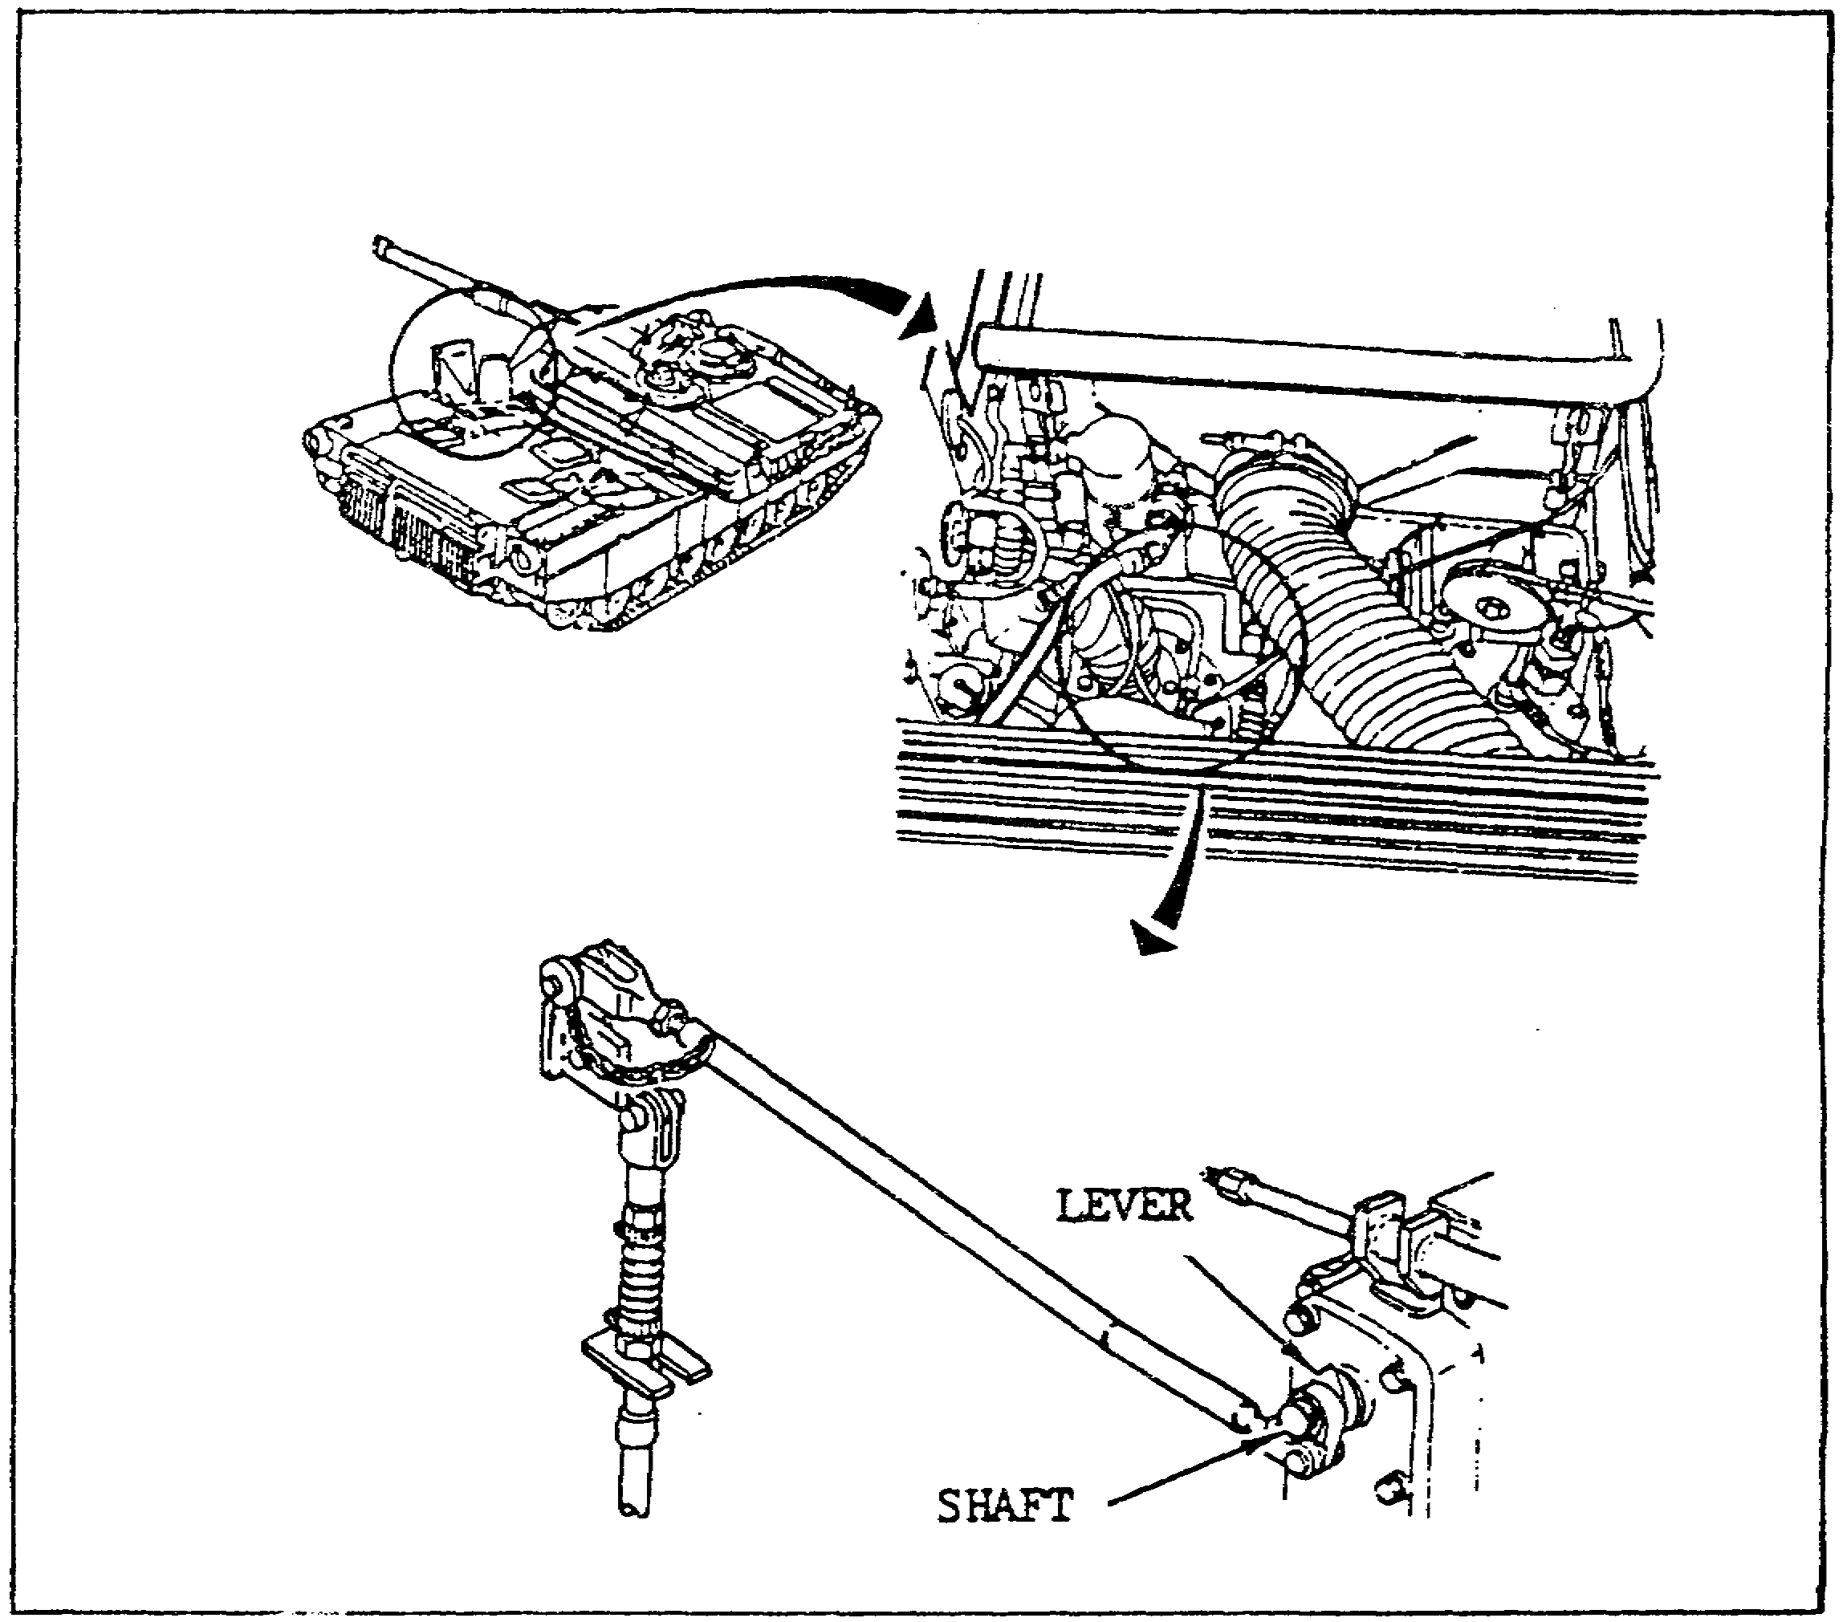

FIGURE 11. STEERING LEVER AND SHAFT.

(1) Open the top deck left side grille doors.

(2) Have the person who is assisting turn the steer-throttle control handles full right and then full left.

(3) While the steer-throttle control handles are being turned, check to see if the lever moves and the shaft rotates.

28

PRINCIPLES & T/S M1 POWER TRAIN - OD 0478 - LESSON 2/TASK 1

(4) If the lever moves and the shaft rotates, the steps in troubleshooting pathway two, described in paragraph 3e on page 31, would be followed. If the lever does not move and/or the shaft does not rotate, the procedures in troubleshooting pathway three would be performed.

d. Pathway One. The first troubleshooting pathway for the fault symptom, NO STEERING CONTROL, contains the step-by-step procedures to be followed if the steer-throttle control handles did not move when the attempt was made to move them right and left.

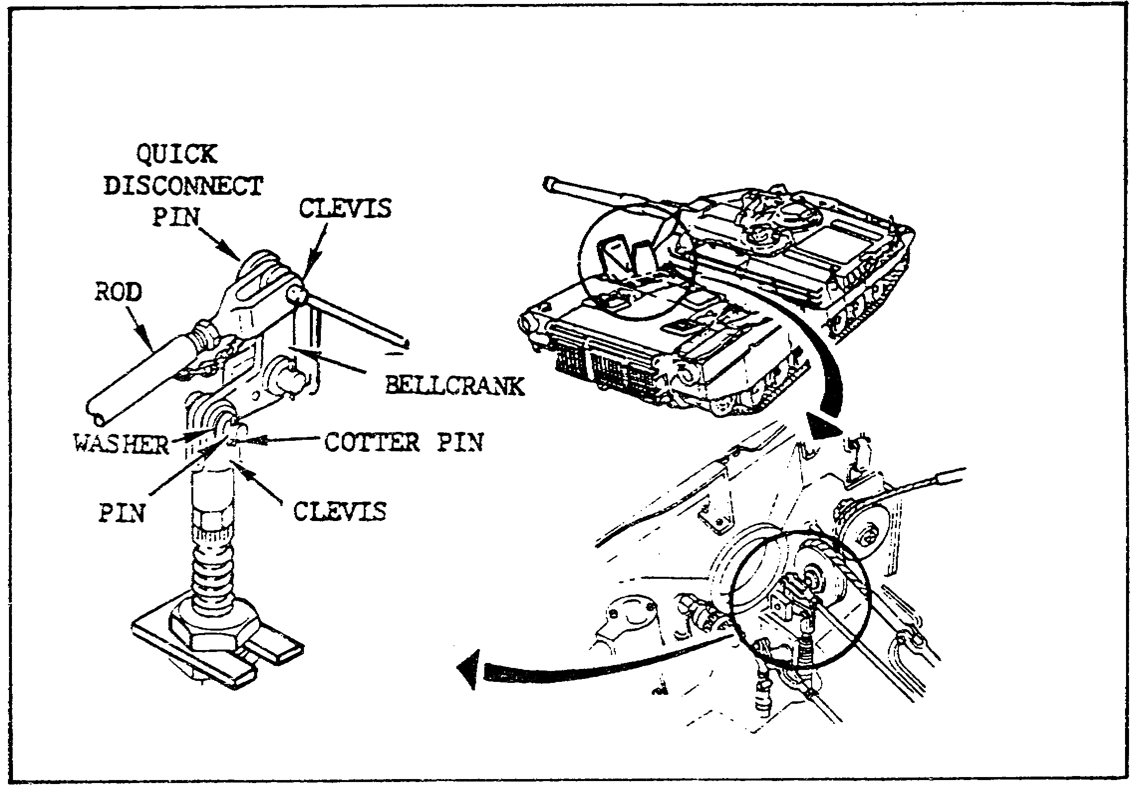

FIGURE 12. THE STEERING LINKAGE.

(1) The first step in this pathway is to check the steering linkage (figure 12) for binding. The steering linkage check tests the possibility that either the transmission or the bellcrank might be faulty. To perform the steering linkage check, follow these steps:

(a) Pull out the quick-disconnect pin from the clevis (upper) and the bellcrank.
29

PRINCIPLES & T/S M1 POWER TRAIN - OD 0478 - LESSON 2/TASK 1

(b) Push and then pull the rod toward the front and rear of the tank.

(c) If the rod did not move, it would be necessary to reconnect the clevis to the bellcrank, using the quick-disconnect pin. The transmission is faulty, and IDS maintenance must be notified. For the purposes of this subcourse, however, assume that the rod did move.

(d) If the rod moves, use long round nose pliers to pull out the cotter pin near the clevis (lower).

(e) Remove the pin and washer from the clevis (lower) and bellcrank.

(f) Try to move the bellcrank up and down.

(g) If the bellcrank did not move freely, it would require replacement, using the instructions in TM 9-2350-255-20-1-3-3. After bellcrank replacement, it would be necessary to verify that the problem has been solved. However, for the purposes of this subcourse, assume that the bellcrank did move freely.

(h) If the bellcrank moves freely, the problem has not yet been located. Connect the clevis (upper) to the bellcrank, using the quick-disconnect pin.

(2) The next check determines whether the steer-throttle control assembly (figure 13 on the following page) is causing the problem.

(a) Remove the steer-throttle control assembly cover.

(b) Use long round nose pliers to pull out the cotter pin.

(c) Take out the pin and washer from the clevis and housing.

(d) Try to move the steer-throttle control handles to full right and then to full left.

(e) If the handles move, the steer-throttle control assembly is causing the problem. It would have to be replaced, using the instructions in TM 9-2350-255-20-1-3-3. Then it would be necessary to

30

PRINCIPLES & T/S M1 POWER TRAIN - OD 0478 - LESSON 2/TASK 1

verify that the problem has been solved. However, for the purposes of this subcourse, assume that the handles would not move.

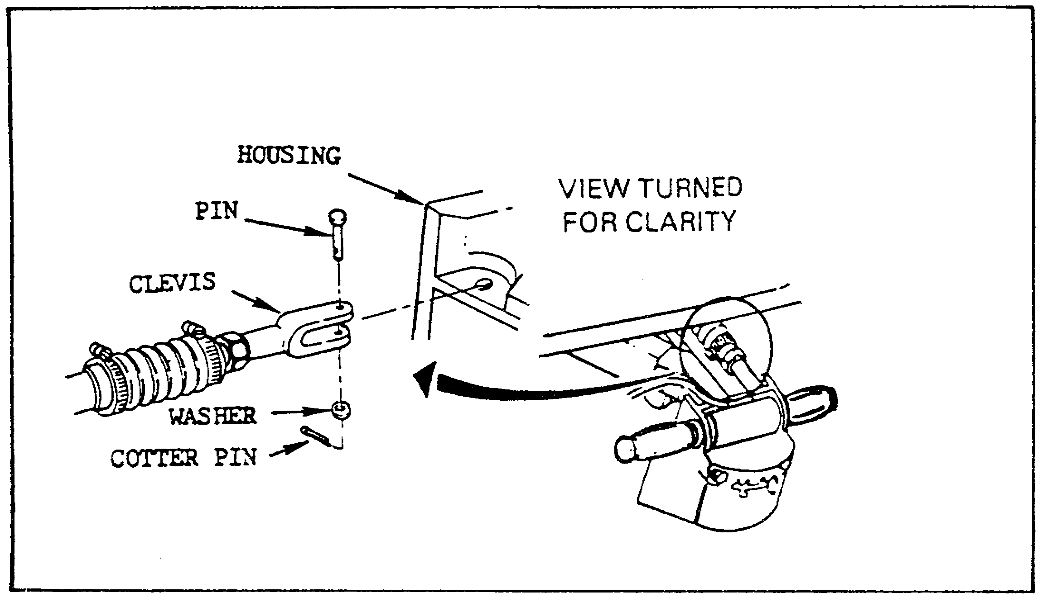

FIGURE 13. THE STEER-THROTTLE CONTROL ASSEMBLY.

(f) If the handles would not move, the problem has not yet been located. It will now be necessary to find out why the steer-throttle control is binding.

(3) If the handles would not move, the steer-throttle control is binding. This could be caused either by the steer-throttle housing or by the driver's control arm (figure 14 on the following page). To find out which component is causing the problem, check the driver's control arm for bends which could cause the steer-throttle control housing to bind.

(a) If the arm is bent, refer to figure 12, on page 29, and connect the clevis (lower) to the bellcrank with the pin and the washer. Insert a new cotter pin. Then replace the driver's control arm, following the instructions in TM 9-2350-255-20-1-3-3. Verify that the problem is solved.

(b) If the arm is not bent, the steer-throttle control housing must be replaced. First connect the clevis (lower) to the bellcrank with the pin and washer. Insert a new cotter pin. Then replace

31

PRINCIPLES & T/S M1 POWER TRAIN - OD 0478 - LESSON 2/TASK 1

the steer-throttle control housing, using the procedures in TM 9-2350-255-20-1-3-3. Then verify that the problem has been solved.

(4) Pathway one ends at this point with the solution to the problem. If the problem has not been solved, repeat the troubleshooting procedures for this symptom.

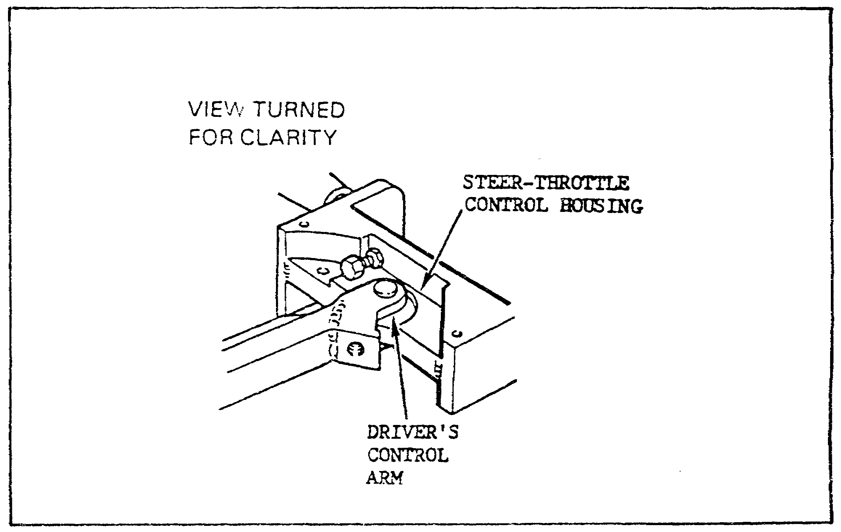

FIGURE 14. DRIVER'S CONTROL ARM.

e. Pathway Two. In the initial checks, an attempt was made to move the steer-throttle control handles right and left. If the handles did move, than a check was made to see if the lever moved and the shaft rotated on the transmission when the steer-throttle control was moved. Pathway two provides the step-by-step procedures to be followed when the lever moved and the shaft rotated on the transmission.

(1) The first step in this pathway is to determine whether the final drives are connected. Refer to figure 15, on the following page, and perform the following steps for both the left and right sides, to determine whether the left and right final drives are connected.

32
PRINCIPLES & T/S M1 POWER TRAIN - OD 0478 - LESSON 2/TASK 1

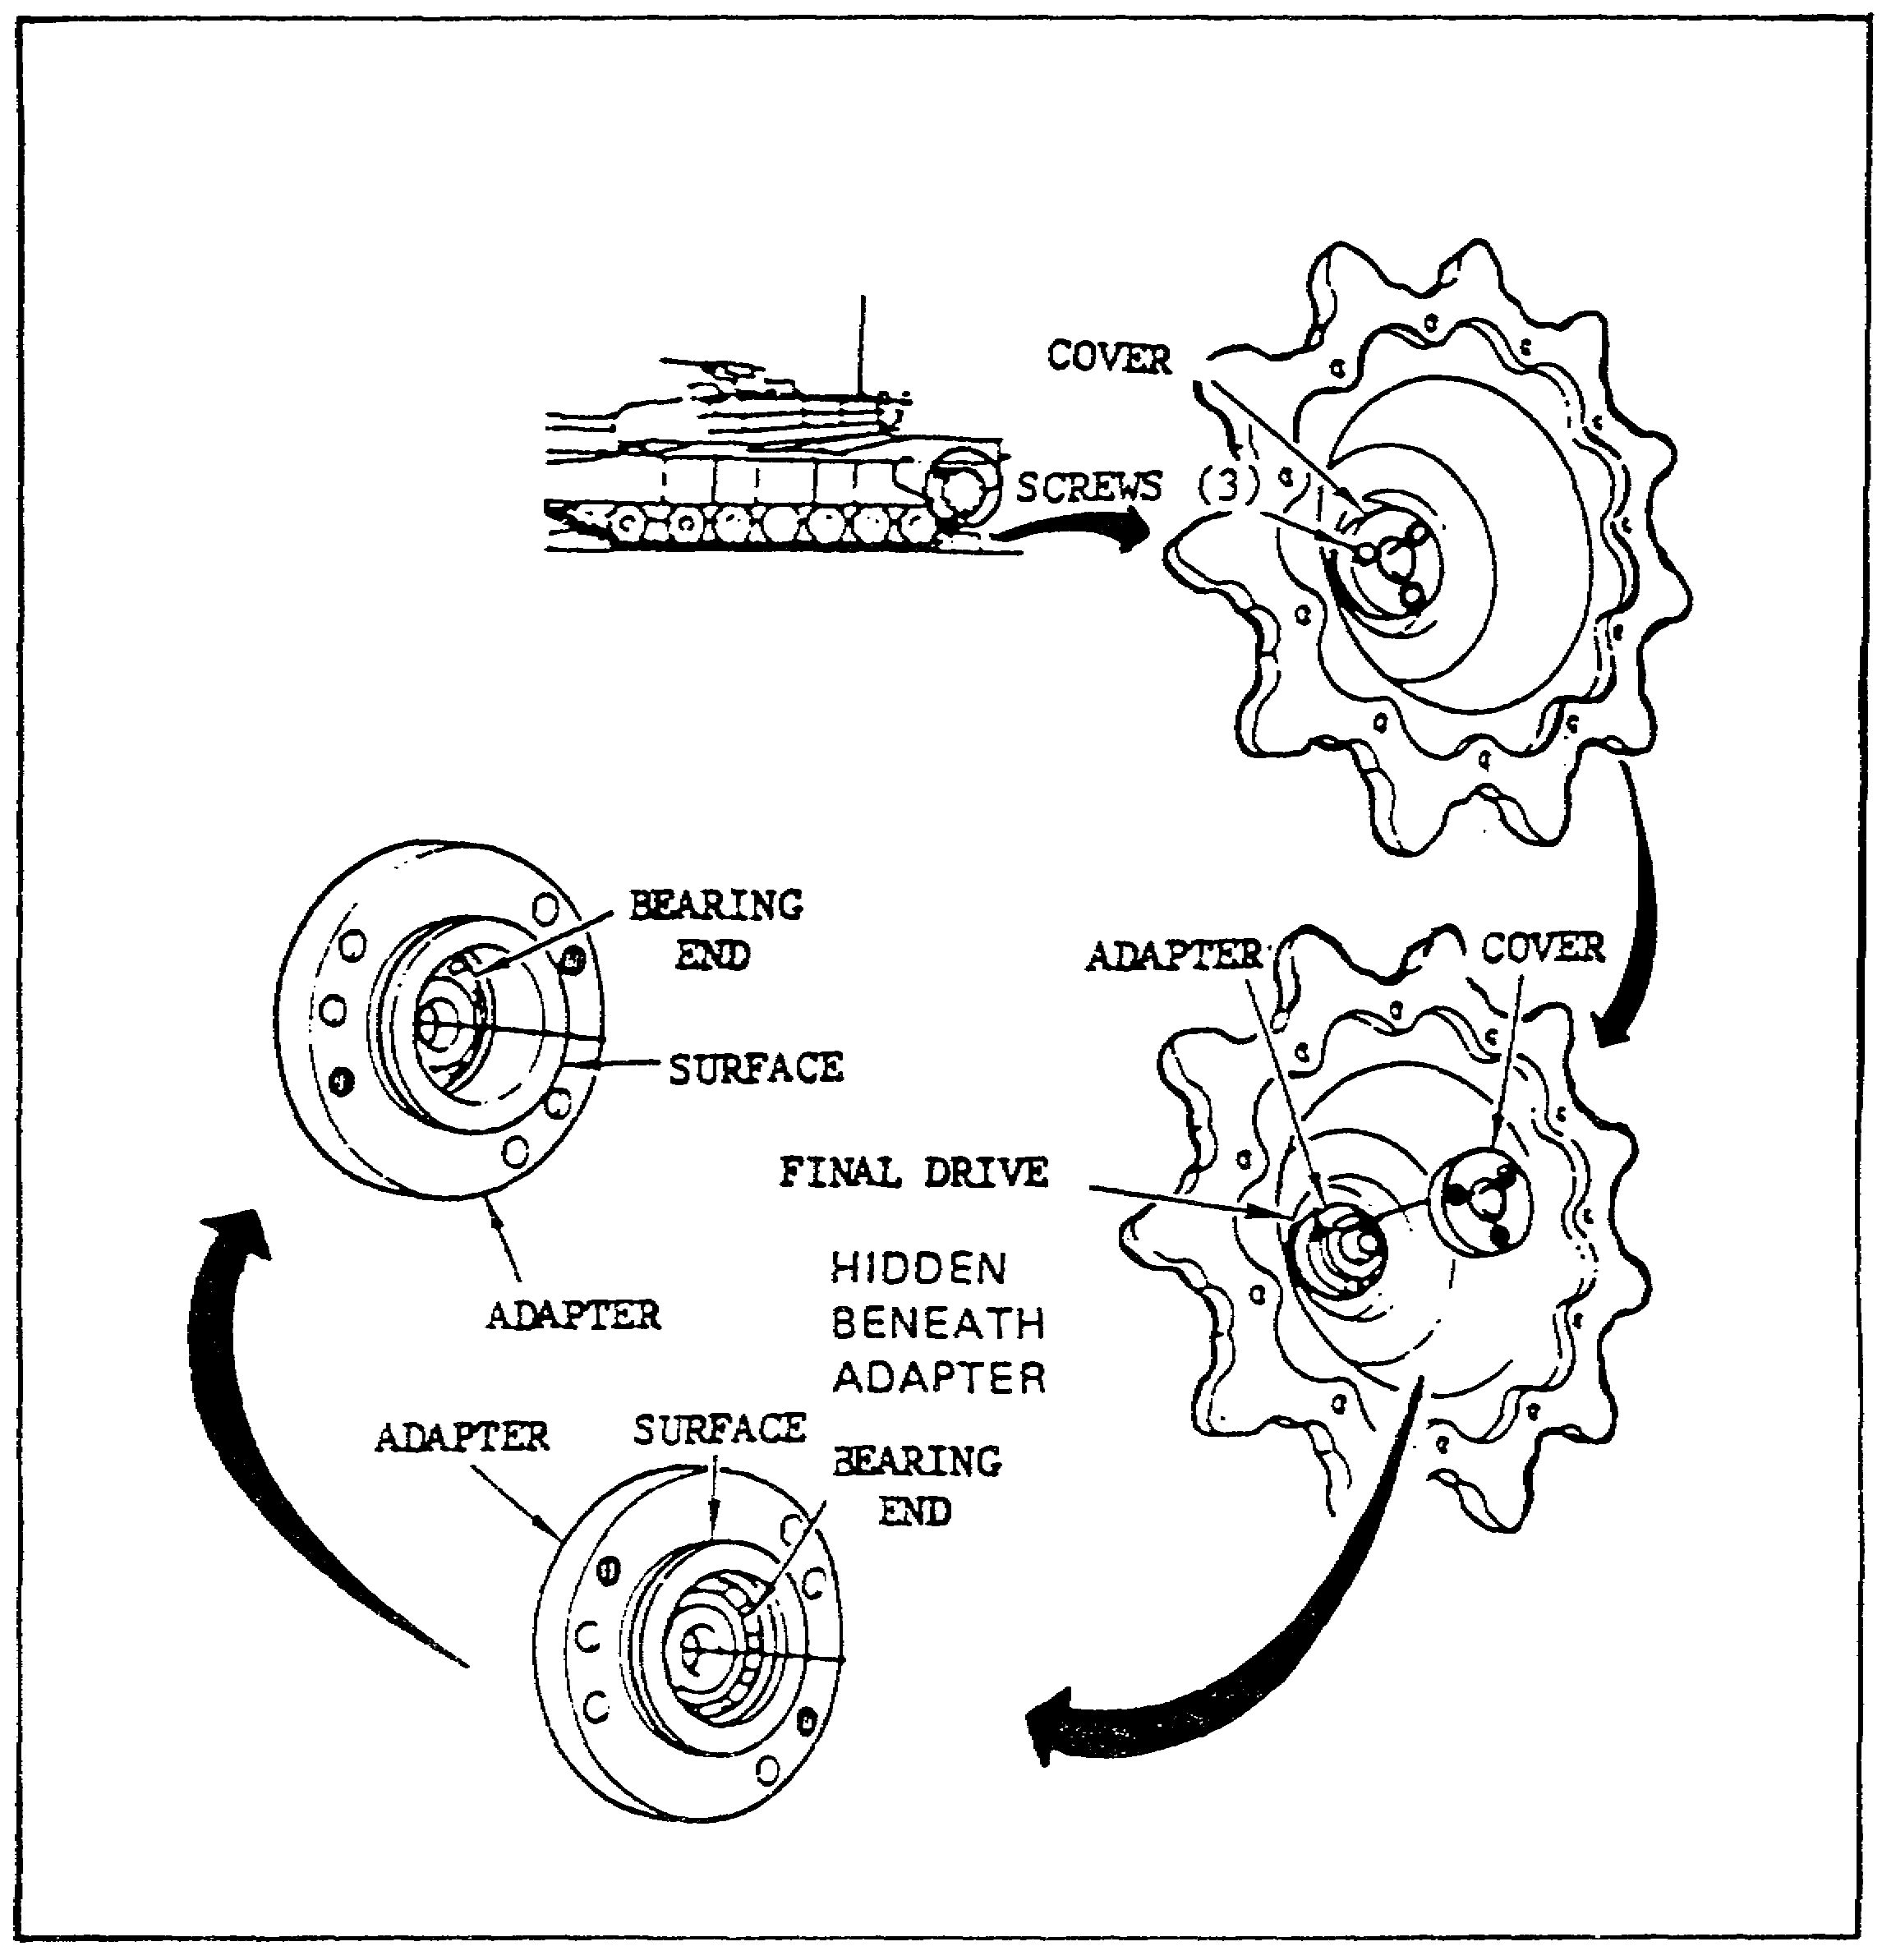

FIGURE 15. CHECKING FOR CONNECTION OF THE FINAL DRIVES.

(a) Use a 13 millimeter socket, 10-inch extension, and handle to unscrew and remove the three screws from the adapter cover. Then pull the cover off the adapter.

(b) Check to see if the bearing end is even with the surface on the adapter.

(c) If the bearing end is even with the surface on the adapter, the final drive being checked is not connected. It must then be connected, using the instructions in TM 9-2350-255-20-1-3-1. For the purposes of this subcourse, however, assume

33

PRINCIPLES & T/S M1 POWER TRAIN - OD 0478 - LESSON 2/TASK 1

that the bearing end is below the surface on the adapter.

(d) If the bearing end is below the surface on the adapter, the final drive being checked is connected. Since the problem has not been located, proceed with the step described in paragraph 3e(2).

(2) If the final drives are both connected, the problem could either be a faulty transmission or a faulty final drive assembly. To determine which, check the torque on both the left and right final drives. The procedures for checking the torque on a final drive can be found, when needed, in TM 9-2350-255-20-1-3-1. These procedures will not be covered in this subcourse.

(a) Any final drive assembly that has a torque of more than 100 inch-pounds must be replaced. The procedure for replacing the left or right final drive can be found in TM 9-2350-255-20-1-3-1, when needed. When the final drive has been replaced, verify that the problem has been solved.

(b) If the torque is not more than 100 inch-pounds on either final drive, the transmission is faulty. Put the cover on the adapter and screw in three screws to attach the cover to the adapter. Notify IDS maintenance that the transmission is faulty.

f. Pathway Three. Pathway three contains the step-by-step procedures to be carried out when the initial checks resulted in steer-throttle control handles that would move but a lever that would not move back and forth, and/or a shaft that would not rotate on the transmission when the handles were moved.

(1) The first step in this pathway is to check to be sure that the clevis on the steering control rod (figure 16 on the following page) is connected to the lever. If it is not connected, it must be connected to the lever. The procedures for connecting the clevis to the lever can be found, if needed, in TM 9-2350-255-20-1-3-3. When the clevis is connected, verify that the problem has been solved. For the purposes of this subcourse, however, assume that the check showed that the clevis was connected to the lever.

34

PRINCIPLES & T/S M1 POWER TRAIN - OD 0478 - LESSON 2/TASK 1

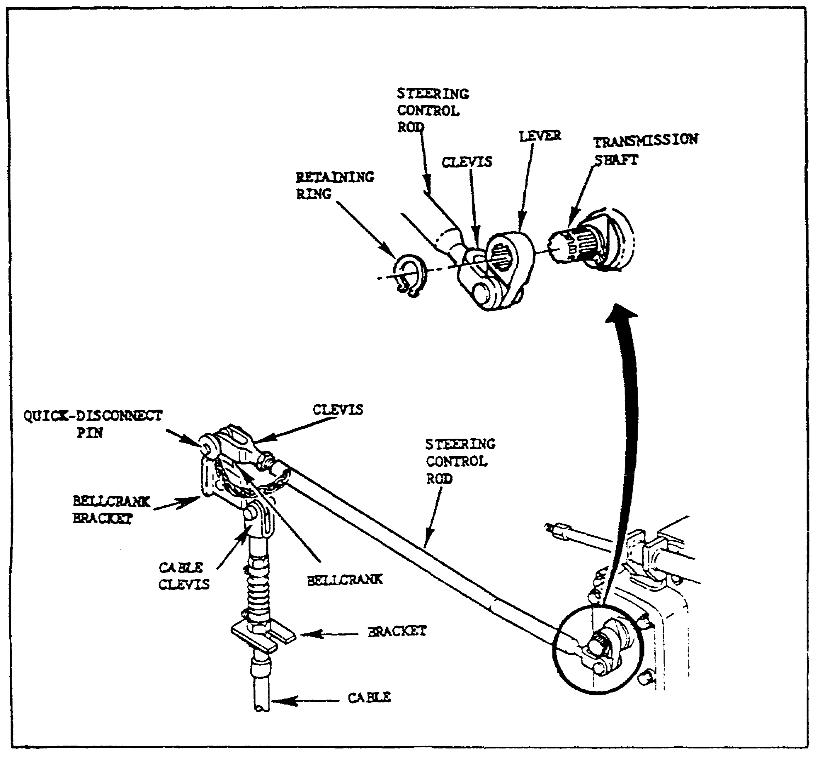

FIGURE 16. THE STEERING CONTROL ROD.

(2) If the clevis is connected to the lever, the problem could be the transmission steering remote control lever. Check the transmission steering remote control lever by performing the following steps:

(a) Use the retaining ring pliers to remove the retaining ring from the transmission shaft.

(b) Grasp the steering control rod and pull the quick-disconnect pin from the clevis and the bellcrank.

(c) Slide the lever off the transmission shaft.

(d) Check the lever for cracks or stripped teeth.

35
PRINCIPLES & T/S M1 POWER TRAIN - OD 0478 - LESSON 2/TASK 1

(e) If the lever is cracked, or the teeth stripped, the transmission steering remote control lever must be replaced, using the instructions in TM 9-2350-255-20-1-3-3. For the purposes of this subcourse, however, assume that the teeth were not stripped and the lever is not cracked.

(3) If the lever was not cracked and the teeth were not stripped, the problem could be caused by the transmission shaft. Check the shaft for cracks or stripped teeth. If cracks or stripped teeth are found, the transmission is faulty, and IDS maintenance must be notified. If this were the case, it would be necessary to connect the clevis to the bellcrank, using the quick-disconnect pin, slide the lever on the shaft, and install the retaining ring on the shaft. For the purposes of this subcourse, however, assume that the shaft was not cracked and the teeth were not stripped.

(4) If the transmission shaft was not cracked and the teeth were not stripped, the problem could be that one or more parts of the steering linkage has become disconnected. Check the steering linkage by following these steps:

(a) Make sure the bellcrank is connected to the bellcrank bracket.

(b) Make sure the clevis on the cable is connected to the bellcrank.

(c) Make sure the cable is connected to the bracket.

(d) If any parts were disconnected, connect them at this time. Then verify that the problem has been solved.

(5) If all parts were connected on the steering linkage, the fault could be a broken steering control rod. Check to see if the rod is broken. If it is, it must be replaced, in accordance with TM 9-2350-255-20-1-3-3. Then verify that the problem has been solved. Assume for this subcourse, however, that the rod was not broken.

(6) If the rod was not broken, perform the following steps:

(a) Connect the clevis to the bellcrank using the quick-disconnect pin.

36

PRINCIPLES & T/S M1 POWER TRAIN - OD 0478 - LESSON 2/TASK 1

(b) Slide the lever on the shaft.

(c) Put the retaining ring on the shaft.

(d) Adjust the steer-throttle control all the way toward the rear of the tank.

(e) Check to make sure that the clevis on the steering control assembly (figure 17) is connected to the housing.

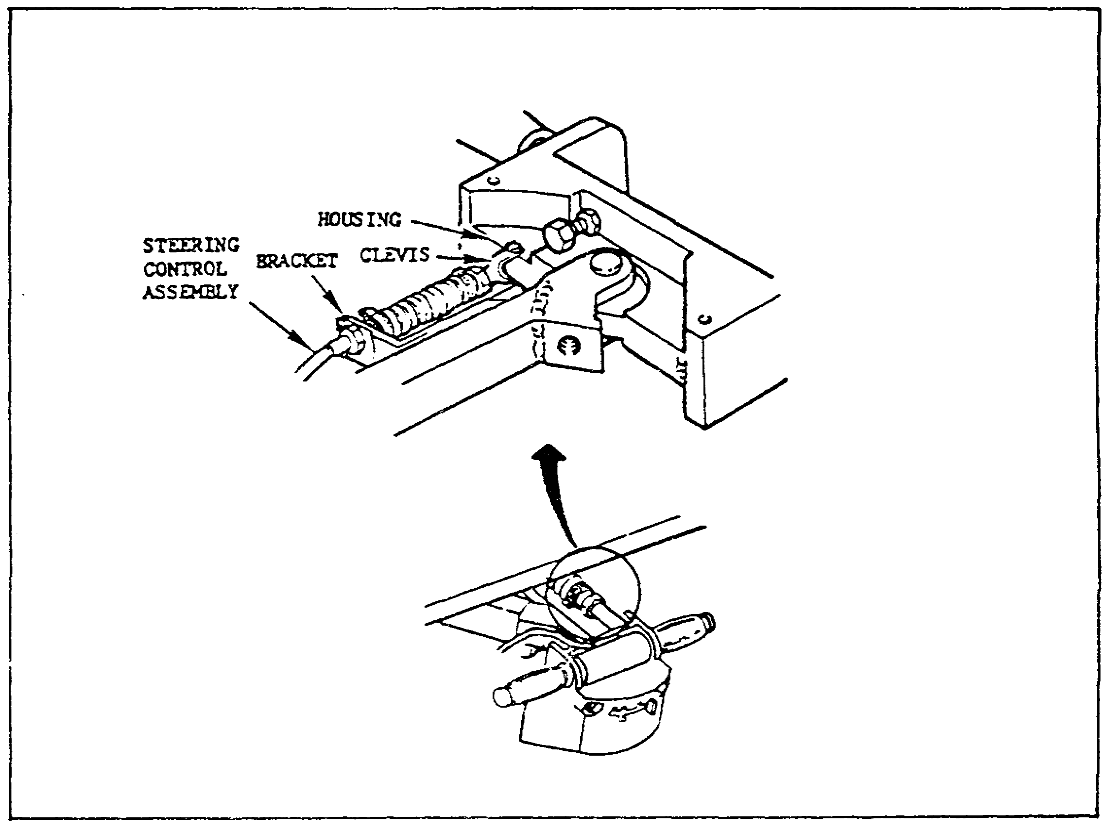

FIGURE 17. STEERING CONTROL ASSEMBLY.

(f) Make sure that the steering control assembly is connected to the bracket.

(g) If any parts are not connected, connect them at this time. Then verify that the problem is solved.

(h) If all parts in this step were connected, the steering control assembly is defective and must be replaced. The procedures for replacing this assembly can be found, when needed, in TM 9-2350-255-20-1-3-3.

37
PRINCIPLES & T/S M1 POWER TRAIN - OD 0478 - LESSON 2/TASK 1

4. Conclusion

Troubleshooting the M1 power train, using these methods and the M1 TMs, is not a difficult task. This sample troubleshooting task is representative of the kinds of troubleshooting procedures that are provided in the TM for the power train fault symptoms. It is important to remember, in any troubleshooting task, that after the fault has been found and the necessary repairs or replacement made, it must by verified that the symptom no longer exists. Accurate troubleshooting and maintenance methods will ensure a safe tank for the M1 crew.

38

PRINCIPLES & T/S M1 POWER TRAIN - OD 0478 - LESSON 2/PE 2

PRACTICAL EXERCISE 2

1. Instructions

Read the scenario and respond to the requirements that follow the scenario.

2. Scenario

Having listened to your explanation of the power train operation, your grandfather laments the good old days when things were much simpler. He wonders how on earth, with all this fancy electronic stuff, you can ever figure out what's gone wrong when something breaks. You explain to him that, in some ways, the new manuals have made the troubleshooting process much easier. Your cousin perks up his ears about this time, because he is just about to start the troubleshooting section in the M1 resident's course.

First Requirement

To illustrate to your grandfather the methods that are used to troubleshoot, you pull out TM 9-2350-255-20-1-2-1. Where would the troubleshooting information listed below be found in that manual?

a. An overall view of the assemblies or components in a system.

b. The number of personnel needed to perform a particular troubleshooting procedure.

c. Whether the simplified test equipment (STE) is needed to troubleshoot for a particular fault symptom.

d. When the STE is required for a troubleshooting task, the test number to be entered on the test set to troubleshoot a fault symptom.

e. Step-by-step troubleshooting instructions.

f. A reference, by figure number, to the detailed instructions for the use of test equipment needed in troubleshooting.

39

PRINCIPLES & T/S M1 POWER TRAIN - OD 0478 - LESSON 2/PE 2

Second Requirement

Your cousin asks you to use an example fault symptom to describe to him how to perform a typical troubleshooting task. You choose the symptom, NO STEERING CONTROL, and choose the pathway that results when the following two conditions are met: (1) the steer-throttle control handles will move, and (2) the lever moves back and forth and the shaft rotates on the transmission when the steer-throttle control handles are moved. List the two checks that must be made and the results of those checks that would lead to the conclusion that the transmission is faulty.

a. First check:

b. First check result:

c. Second check:

d. Second check result:

40

PRINCIPLES & T/S M1 POWER TRAIN - OD 0478 - LESSON 2/PE 2

LESSON 2. PRACTICAL EXERCISE - ANSWERS

First Requirement

a. Troubleshooting charts (roadmaps).

b. The Fault Symptom Index for that system.

c. The Fault Symptom index for that system.

d. The Troubleshooting Procedures System Fault Symptom Index.

e. The Troubleshooting Flowcharts.

f. The Test Equipment Procedures Index.

Second Requirement

a. First Check: Check to see that both the left and right final drives are connected.

b. First Check Result: Both final drives are connected.

c. Second Check: Check the torque on each final drive.

d. Second Check Result: The torque is not more than 100 inch-pounds on either the left or the right final drive. Therefore, the transmission is faulty.

41

PRINCIPLES & T/S M1 POWER TRAIN - OD 0478 - REFERENCES

REFERENCES

The following documents were used as resource materials in developing this subcourse:

TM 9-2350-255-10-1
TM 9-2350-255-10-2
TM 9-2350-255-10-3
TM 9-2350-255-20-1-2-1
TM 9-2350-255-20-1-3-1
TM 9-2350-255-20-1-3-3

42

